## ASSIGNMENT NO: 1

Title: Single node/Multiple node Hadoop Installation. Learning Objectives:

**Problem Statement:** Study and perform Hadoop Installation on a)Single Node b)Multiple Node

**Software and Hardware Requirement:** PC with Ubuntu

**Theory:**

**What is Hadoop:**

Apache Hadoop is an open source framework that is used to efficiently store and process large datasets ranging in size from gigabytes to petabytes of data. Instead of using one large computer to store and process the data, Hadoop allows clustering multiple computers to analyze massive datasets in parallel more quickly.

Hadoop consists of four main modules:

* Hadoop Distributed File System (HDFS) – A distributed file system that runs on standard or low- end hardware. HDFS provides better data throughput than traditional file systems, in addition to high fault tolerance and native support of large datasets.
* Yet Another Resource Negotiator (YARN) – Manages and monitors cluster nodes and resource usage. It schedules jobs and tasks.
* MapReduce – A framework that helps programs do the parallel computation on data. The map task takes input data and converts it into a dataset that can be computed in key value pairs. The output of the map task is consumed by reduce tasks to aggregate output and provide the desired result.
* Hadoop Common – Provides common Java libraries that can be used across all modules.

Steps to install Hadoop on Ubuntu:

sudo apt-get update

sudo apt install openjdk-8-jdk cd /usr/lib/jvm

ls cd

sudo nano .bashrc

//add following lines at the end

export JAVA_HOME=/usr/lib/jvm/java-8-openjdk-amd64 export PATH=$PATH:/usr/lib/jvm/java-8-openjdk-amd64/bin

export HADOOP_HOME=~/hadoop-3.3.4/ export PATH=$PATH:$HADOOP_HOME/bin export PATH=$PATH:$HADOOP_HOME/sbin

export HADOOP_MAPRED_HOME=$HADOOP_HOME

export YARN_HOME=$HADOOP_HOME

export HADOOP_CONF_DIR=$HADOOP_HOME/etc/hadoop

export HADOOP_COMMON_LIB_NATIVE_DIR=$HADOOP_HOME/lib/native export HADOOP_OPTS="-Djava.library.path=$HADOOP_HOME/lib/native"

export HADOOP_STREAMING=$HADOOP_HOME/share/hadoop/tools/lib/hadoop-streaming-3.3.4.jar export HADOOP_LOG_DIR=$HADOOP_HOME/logs

export PDSH_RCMD_TYPE=ssh

//ctrl+o, enter, ctrl+x sudo apt-get install ssh

tar -zxvf ~/Downloads/hadoop-3.3.4.tar.gz cd hadoop-3.3.4/etc/hadoop

ls

sudo nano hadoop-env.sh

//uncomment JAVA_HOME JAVA_HOME=/usr/lib/jvm/java-8-openjdk-amd64 (set the path for JAVA_HOME)

//ctrl+o, enter, ctrl+x sudo nano core-site.xml

//add configuration at the end

<configuration>

<property>

<name>fs.defaultFS</name>

<value>hdfs://localhost:9000</value> </property>

<property>

<name>hadoop.proxyuser.dataflair.groups</name> <value>*</value>

</property>

<property>

<name>hadoop.proxyuser.dataflair.hosts</name> <value>*</value>

</property>

<property>

<name>hadoop.proxyuser.server.hosts</name> <value>*</value>

</property>

<property>

<name>hadoop.proxyuser.server.groups</name> <value>*</value>

</property>

</configuration>

//ctrl+o, enter, ctrl+x sudo nano hdfs-site.xml

//add configuration at the end

<configuration>

<property>

<name>dfs.replication</name>

<value>1</value>

</property>

</configuration>

//ctrl+o, enter, ctrl+x

sudo nano mapred-site.xml

//add configuration at the end

<configuration>

<property>

<name>mapreduce.framework.name</name> <value>yarn</value>

</property>

<property>

<name>mapreduce.application.classpath</name>

<value>$HADOOP_MAPRED_HOME/share/hadoop/mapreduce/*:$HADOOP_MAPRED_HOME/share/hadoop/mapre duce/lib/*</value>

</property>

</configuration>

//ctrl+o, enter, ctrl+x sudo nano yarn-site.xml

//add configuration at the end

<configuration>

<property>

<name>yarn.nodemanager.aux-services</name>

<value>mapreduce_shuffle</value>

</property>

<property>

<name>yarn.nodemanager.env-whitelist</name>

<value>JAVA_HOME,HADOOP_COMMON_HOME,HADOOP_HDFS_HOME,HADOOP_CONF_DIR,CLASSPAT H_PREP END_DISTCACHE,HADOOP_YARN_HOME,HADOOP_MAPRED_HOME</value>

</property>

</configuration>

//ctrl+o, enter, ctrl+x ssh localhost

ssh-keygen -t rsa -P '' -f ~/.ssh/id_rsa

cat ~/.ssh/id_rsa.pub >> ~/.ssh/authorized_keys chmod 0600 ~/.ssh/authorized_keys

hadoop-3.3.4/bin/hdfs namenode -format export PDSH_RCMD_TYPE=ssh

start-all.sh

//open in browser localhost:9870

Ouptut:

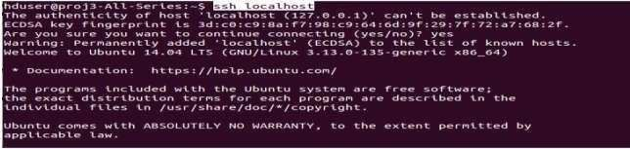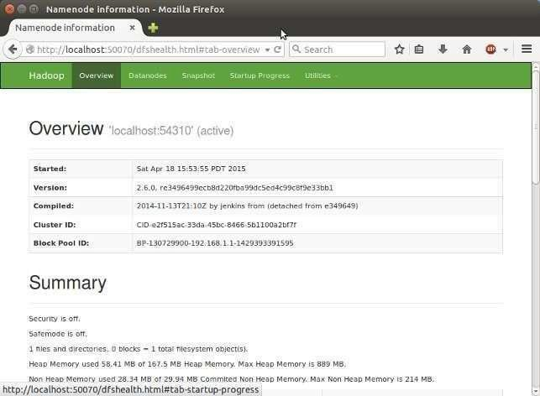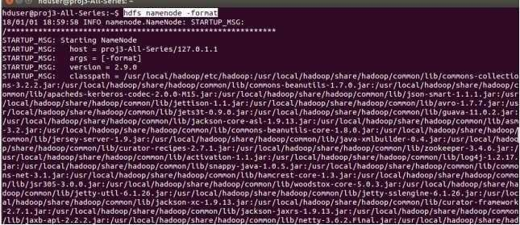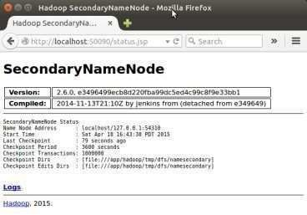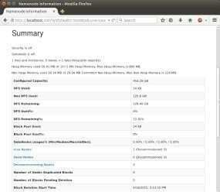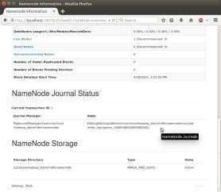

**Conclusion:** Single node and multi-node installation of hadoop .

`

## ASSIGNMENT NO: 2

Title: Design a distributed application using MapReduce(Using Java) which processes a log file of a system. List out the users who have logged for maximum period on the system. Use simple log file from the Internet and process it using a pseudo distribution mode on Hadoop platform.Learning Objectives:

**Problem Statement:** Study and perform program using map reduce on Hadoop.

**Software and Hardware Requirement:** Implement mapreduce on Ubuntu.

**Theory:**

What is MapReduce?

MapReduce is a processing technique and a program model for distributed computing based on java. The MapReduce algorithm contains two important tasks, namely Map and Reduce. Map takes a set of data and converts it into another set of data, where individual elements are broken down into tuples (key/value pairs). Secondly, reduce task, which takes the output from a map as an input and combines those data tuples into a smaller set of tuples. As the sequence of the name MapReduce implies, the reduce task is always performed after the map job.

The major advantage of MapReduce is that it is easy to scale data processing over multiple computing nodes. Under the MapReduce model, the data processing primitives are called mappers and reducers. Decomposing a data processing application into *mappers* and *reducers* is sometimes nontrivial. But, once we write an application in the MapReduce form, scaling the application to run over hundreds, thousands, or even tens of thousands of machines in a cluster is merely a configuration change. This simple scalability is what has attracted many programmers to use the MapReduce model.

The Algorithm

* Generally MapReduce paradigm is based on sending the computer to where the data resides!
* MapReduce program executes in three stages, namely map stage, shuffle stage, and reduce stage.
* **Map stage** − The map or mapper’s job is to process the input data. Generally the input data is in the form of file or directory and is stored in the Hadoop file system (HDFS). The input file is passed to the mapper function line by line. The mapper processes the data and creates several small chunks of data.
* **Reduce stage** − This stage is the combination of the **Shuffle** stage and the **Reduce** stage. The Reducer’s job is to process the data that comes from the mapper. After processing, it produces a new set of output, which will be stored in the HDFS.
* During a MapReduce job, Hadoop sends the Map and Reduce tasks to the appropriate servers in the cluster.
* The framework manages all the details of data-passing such as issuing tasks, verifying task completion, and copying data around the cluster between the nodes.
* Most of the computing takes place on nodes with data on local disks that reduces the network traffic.
* After completion of the given tasks, the cluster collects and reduces the data to form an appropriate result, and sends it back to the Hadoop server.

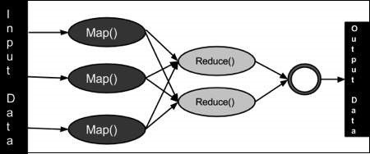

Inputs and Outputs (Java Perspective)

The MapReduce framework operates on <key, value> pairs, that is, the framework views the input to the job as a set of <key, value> pairs and produces a set of <key, value> pairs as the output of the job, conceivably of different types.

The key and the value classes should be in serialized manner by the framework and hence, need to implement the Writable interface. Additionally, the key classes have to implement the Writable-Comparable interface to facilitate sorting by the framework. Input and Output types of a **MapReduce job** − (Input) <k1, v1> → map →

<k2, v2> → reduce → <k3, v3>(Output).

Implementation Steps:

1. Create folder Data on Desktop and copy all given files(i. access_log_short.txt – Data set to analyze
2. SalesCountryDriver.java : Manages input and output from Mapper and Reducer
3. SalesMapper.java : Reads input file
4. SalesCountryReducer.java : Reads the input from mapper file)
5. Open file named access_log_short.txt using libreoffice/wps and use separator as “-” (Uncheck remaining options), save the file as text CSV format
6. su – hduser (Change the user)
7. Sudo mkdir analyzelogs (Create folder analyzelogs)

and copy the contents of Data folder into analyzelogs folder using command

1. sudo cp /home/ll01/Desktop/Data/* ~/analyzelogs
2. Give permissions using

sudo chmod -R 777 analyzelogs /

1. Change the owner to hduser using following sudo chown -R hduser analyzelogs /
2. cd analyzelogs
3. sudo chmod +r *.*
4. export CLASSPATH="$HADOOP_HOME/share/hadoop/mapreduce/hadoop- mapreduce-clientcore- 2.9.0.jar:$HADOOP_HOME/share/hadoop/mapreduce/hadoop- mapreduce-client- common2.9.0.jar:$HADOOP_HOME/share/hadoop/common/hadoop- common2.9.0.jar:~/analyzelogs/SalesCountry/*:$HADOOP_HOME/lib/*"
5. sudo gedit Manifest.txt
6. Add following line and press enter and save the file Main-Class: SalesCountry.SalesCountryDriver
7. javac -d . SalesMapper.java SalesCountryReducer.java SalesCountryDriver.java
8. jar -cfm analyzelogs.jar Manifest.txt SalesCountry/*.class
9. start-dfs.sh
10. Start-yarn.sh
11. jps
12. cd analyzelogs/
13. sudo mkdir ~/input
14. sudo cp access_log_short.csv ~/input/

Input:

1. **Mapper file-**

package SalesCountry; import java.io.IOException;

import org.apache.hadoop.io.IntWritable; import org.apache.hadoop.io.LongWritable; import org.apache.hadoop.io.Text; import org.apache.hadoop.mapred.*;

public class SalesMapper extends MapReduceBase implements Mapper<LongWritable, Text, Text, IntWritable> { private final static IntWritable one = new IntWritable(1);

public void map(LongWritable key, Text value, OutputCollector<Text, IntWritable> output, Reporter reporter) throws IOException {

String valueString = value.toString();

String[] SingleCountryData = valueString.split("-"); output.collect(new Text(SingleCountryData[0]), one);

}

}

1. **Reducer file:**

package SalesCountry;

import java.io.IOException; import java.util.*;

import org.apache.hadoop.io.IntWritable; import org.apache.hadoop.io.Text; import org.apache.hadoop.mapred.*;

public class SalesCountryReducer extends MapReduceBase implements Reducer<Text, IntWritable, Text, IntWritable> {

public void reduce(Text t_key, Iterator<IntWritable> values, OutputCollector<Text,IntWritable> output, Reporter reporter) throws IOException {

Text key = t_key;

int frequencyForCountry = 0; while (values.hasNext()) {

// replace type of value with the actual type of our value IntWritable value = (IntWritable) values.next(); frequencyForCountry += value.get();

}

output.collect(key, new IntWritable(frequencyForCountry));

}

}

1. **Driver File package SalesCountry;**

import org.apache.hadoop.fs.Path; import org.apache.hadoop.io.*; import org.apache.hadoop.mapred.*;

public class SalesCountryDriver {

public static void main(String[] args) { JobClient my_client = new JobClient();

// Create a configuration object for the job

JobConf job_conf = new JobConf(SalesCountryDriver.class);

// Set a name of the Job job_conf.setJobName("SalePerCountry");

// Specify data type of output key and value job_conf.setOutputKeyClass(Text.class); job_conf.setOutputValueClass(IntWritable.class);

// Specify names of Mapper and Reducer Class job_conf.setMapperClass(SalesCountry.SalesMapper.class); job_conf.setReducerClass(SalesCountry.SalesCountryReducer.class);

// Specify formats of the data type of Input and output job_conf.setInputFormat(TextInputFormat.class); job_conf.setOutputFormat(TextOutputFormat.class);

// Set input and output directories using command line arguments,

//arg[0] = name of input directory on HDFS, and arg[1] = name of output directory to be created to store the output file.

FileInputFormat.setInputPaths(job_conf, new Path(args[0])); FileOutputFormat.setOutputPath(job_conf, new Path(args[1]));

my_client.setConf(job_conf); try {

// Run the job JobClient.runJob(job_conf);

} catch (Exception e) { e.printStackTrace();

}

}

}

Output:

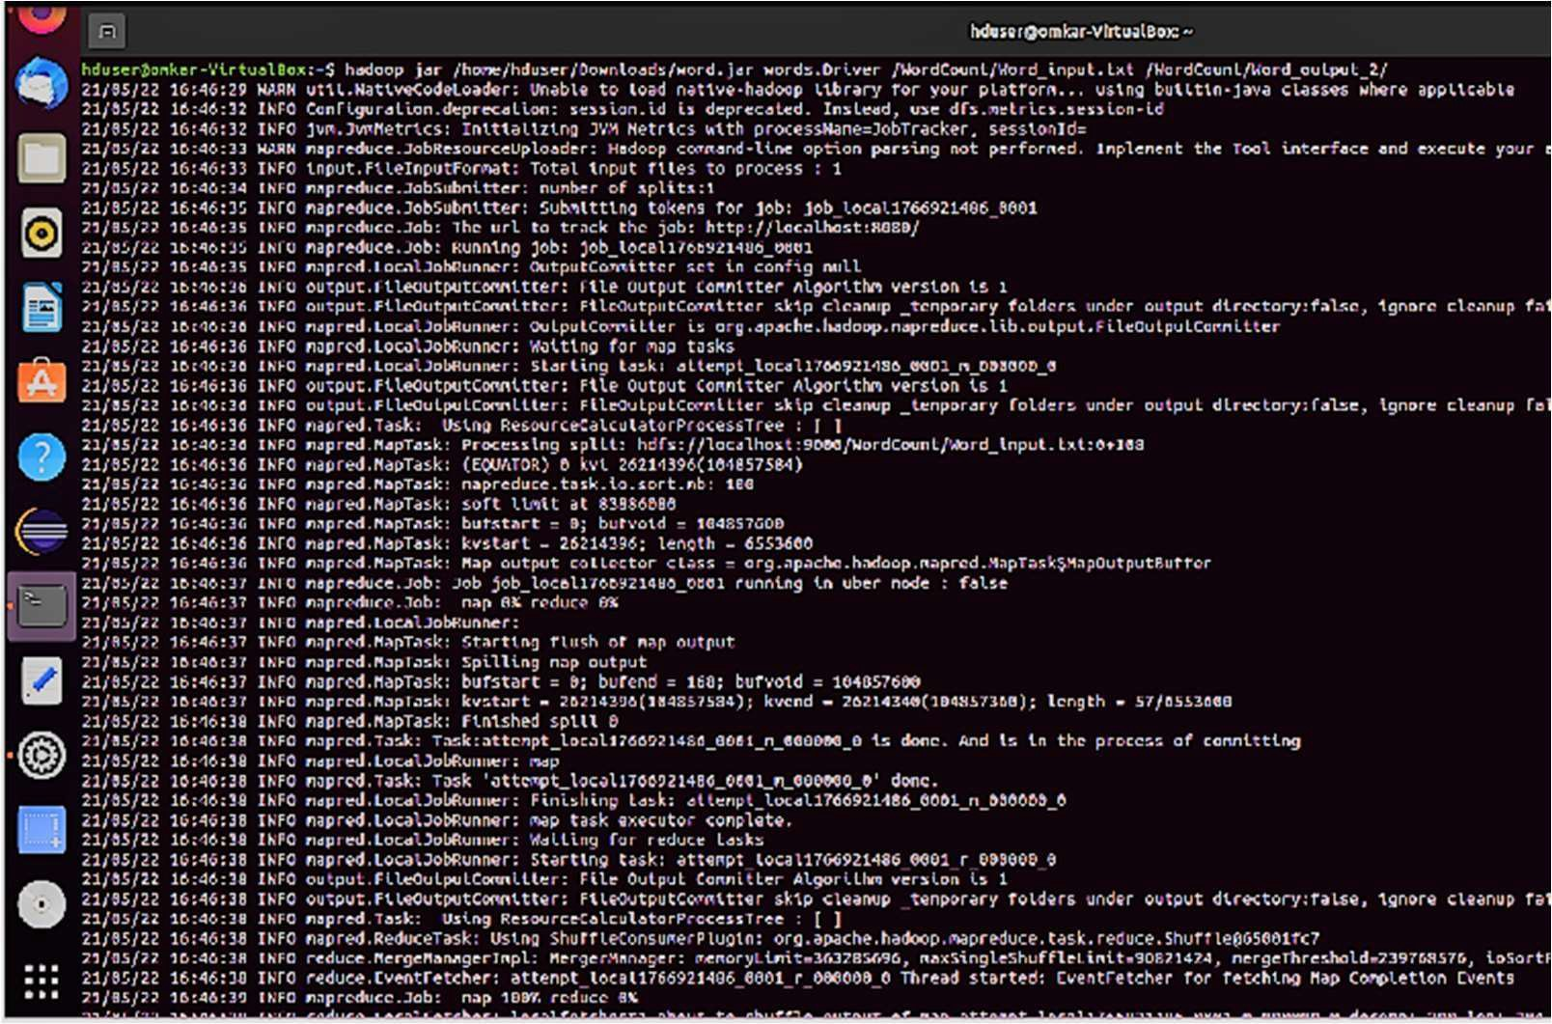

r,i hdvMirg>gmlu-Vfrlu 11iox -

21185/22 :10:'1b:'11 JNFO napred.Loca\. •>bRu.,ner: n•::'oce,. reduce-

|  |
| --- |
| 21/85/22 |
| ZJ/05/22 |
| 71/o:,,/'77 |
| ::!l/OS/22 |
| 21/8':./n. |

16:4U:4t JNFO napr.:d. T.J3k: Task ·.:ittcnpt_Lo:.:ill766'2.148r._coe1_,_E•D8098_0. dor.c.

J0:40:41 JNFO n.>prc•:I.Loc.>\. ot-f':u:incr: F\r,t.-.hlng t.>-. ;: att-::l"lpt \.oc.>'l.17,Ci?2HeO COO,J *r* Ot'(oO t, O

,,1,c e

lrffO n.-.pr"d.10.::.-.lJc.hftu.,n r: rr-c' -::,. ,cr-r11tor conpletr.

1G:-H,:4\

l'!"'''

10:10:'12 lti o ,,.,i,,,,d..,11;0::.J,;,l,; rnp lOl)'S, .., "'

S•JCCeHrully

conpl. ted

B:-S6:4:?. JtffO napredtJC .Jc-t.-: J:> J"'.'b_lc-cal1Uici 140f._&a51

d"ce.Job:

21185/21. fo:'1b:'1l JNFO napre

(ount"rc;

r

nL;.:

.yc;-."I'

J'"JI

Fl. lf'.'

4unb:r

C:>:.int'<.'r:::: JS

b:.,,tc-:; rc.ld-33 e

of

F': rlunbr-r *of* b:,,tr-!I. wri<::tr-n..9 F'.P..40

* .U.!:: m.inber or re3d oj)eratton ..t'

FIL::: ri,.11,bt.>r <of ts1r9,;, re l.l c,p,;,r.itlur,s=O

nL::: W.1nbc-r or Mr1..tc 011-Cr.:it\•>n:;.=e HOF5: Fl•.1nhN of

b:.,,tc-::. wri.":.tcn..

t,:,.,ti::-s. reall=21(,

•H)

tc:lt-S: Flunbcr of

14'.)S'5: tlo..mb,,., or n•od "P"'"li.on':.•ll

tl•Jt1lot"f vr

or

m.inber

t.u9e re3d operat\on!:-a

FS:

.Nap-ncc:ucc rran,:-work

|  |  |  |  |  |  |  |  |
| --- | --- | --- | --- | --- | --- | --- | --- |
| r<\ar,, \n"ut r c;;ords-lS | | | | | | | |
| M.ip | output |  | rcc |  |  | rd | * ■1 |
| f"lop output | | | :it.o:s-H,£ | | | | |

Mfl.l':.' v f<lt\•)11!>=·1

o S

pltt

lllP1Jt

output l"J!terl.'ltll tiyte -204

Conbtnc·

1.npu-:

records.-,

outi:1Jt

r,xor-d;;.=O

tlyte:::=:111

COnb\ne

l'l.,p

(n,-)-

-1

cutpulo;;

,...,

Shufn,r-

l'las:s "1

Shuff\.c-d

'5= 31)

ll co rd

SJ•1. l lo;-d

recor-ds.=5

Reduc,;,,

r ,:ord,--1

b1L

':.l,urn.,.

GC tl.ne

1.nput



u!:.aQe

•>1Jt1>u-:

Map

Rt"duct" 1.nput group• ":.

|  |  |
| --- | --- |
| .■ |  |
| ,e,- | |

R,:,d, ce,

o:-.l•JC

e :!.C,•l

F11i.lr-d Mt,rged

Q

t;,i;.,;,:,J

Tot31.

Sh•Jffle

811.D_lO=O

Errors

heap

comtc-ted

(b tes)=JSU!e5110

CilNNFCTtCa11-!

|  |  |  |
| --- | --- | --- |
| i-'.Oi-'. | | -0 |
| C | LE Tl"..=C) | |

10 L

L, :f)N

1- 0NC.= P.:c&

Fllc-

|  |  |  |  |  |  |  |
| --- | --- | --- | --- | --- | --- | --- |
| l | | , O | NC._ REDVCE-() | | | |
| Tr- | .put := | | | orn | .,t Ccu | ntcro |

syto:':. F-.e.:td-Jes

I l t

Outp,ut t ornat C<11Jnter

!I. lo:::. W, i.tlt,11=.,ii,

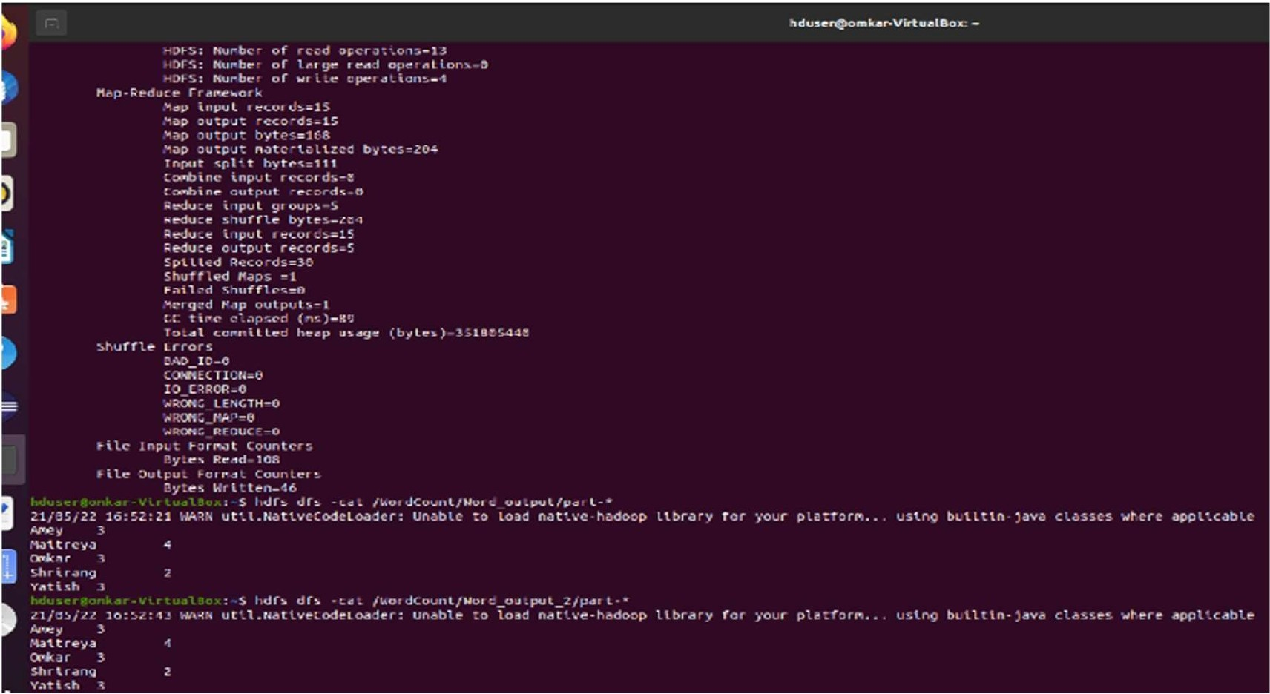

r,i hdvMlrg>gmlu-Vfrlu 11iox -

11,..1,ce



:10:'1b:'11 JNFO napred.Loca\. •>bRu.,ner: r-e-::"oce,. reduce-

16:4U:4t JNFO na1>r.:d. T.J.;k: ·.:ittcnpt_Lo:.:il1766'2.t48r._coe1_,_E•D8098_o· dor.c.

J0:40:41 JNFO n.>prcd.loc.>\. ot-f':u:incr: F\r,t.-.hlng t,:,-. ;: att-::l"lpt \.oc.>'l.17,Ci?2HeO COO,J *r* Ot'(oO t, O

10:10:'12 lti o ,,.,i,,,,d..,11;0::.J,;,l,; r-up lOl)'S, .., "' l'!"'''

lrffO n.-.pr"d.10.::.-.lJc.hftu.,n r: rr-c' ,::, ,cr-r11tor conplrtr.

B:-S6:4:?. JtffO napredtJC .Jc-t.-: J:> J"'.'b_lc-cal1Uici 140f._&a51

JNFO napred"ce.Job: C:>:.int'<.'r:::: JS

r4

S•JCCeHrully

21185/21.

* .U.!:: m.inber FIL:::

nL::: HOF5: l

F': tlunb'°r *of*

oj)eratton ..t'

Mr1..tc 011-Cr.:it\•>n:;.=e

t,:,.,ti::-s. reall=21(,

tc:lt-S:

14'.)S'5: tl•.mb,,., or C"od

m.inber or re3d operat\on!:-a

FS: tl•Jt1lot"f vr Mfl.l':.' v f<lt\•)11!>=·1

.Nap-ncc:ucc rran,:-work

of

Flunbcr

* .1nhN of

F

W.1nbc-r or

tl•.11,bt.>r <of

or

t.u9e

"P"'"li.on':.•ll

b:.,,tc-::. wri.":.tcn••H)

ts1r9,;, re l.l c,p,;,r.itlur,s=O

re3d

b:,,tr-!I.

b:.,,tc-:; rc.ld-33 e

b:r

un

nL;.:

ount"rc;

.yc;-."I' (

Fl. lf'.'

fo:'1b:'1l

\n"ut r c;;ords-lS

wri<::tr-n..9 F'.P..40

J'"JI

1G:-H,:4\

Task

of

conpl. ted

lllP1Jt

Conblnc·

pltt

output l"J!ter1..'llll tiyte -204

,£

tlyte:::=:111

1.npu-:

records.-,

outi:1Jt

r,xor-d;;.=O

COnb\ne

Reduc,;,,

'5= 31)

ll co rd

SJ•1. l lo;-d

recor-ds.=5

•>1Jt1>u-:

r ,:ord,--1

b1Le,,e,

':.l,urn.,.

1.nput

|  |
| --- |
| 21185/22 |
| 21/85/22 |
| ZJ/05/22 |
| 71/o:,,/'77 |
| ::!l/OS/22 |
| 21/8':./n. |

r<\ar,,

M.ip output rccord•■1S f"lop output :it.o:s-H Map

Rt"duct" 1.nput group•.■":.

R,:,d, ce, o:-.l•JC

-:!.C,•l

|  |  |  |  |
| --- | --- | --- | --- |
| Mt,rged | l'l.,p | |  |
| GC tl.ne t;, | | i;.,; | |

(b tes)=JSUIIH110

l'las:s "1

F11i.lr-d ,...,Q

cutpulo;;-1

,:,J (n,-)-

Tot31. comtc-ted heap u!:.aQe Sh•Jffle Errors

811.D_lO=O

Shufn,r-

Shuff\.c-d

CilNNFCTtCa11-!

10 L i-'.Oi-'.-0

LE Tl"..=C)

L, :f)NC

1- 0NC.= P.:c&

l, ONC._ REDVCE-()

Fllc- Tr-.put :=orn.,t Ccuntcro

syto:':. F-.e.:td-Jes

I l t Outp,ut t ornat C<11Jnter

!I. lo:::. W, i.llt,11=.,ii,



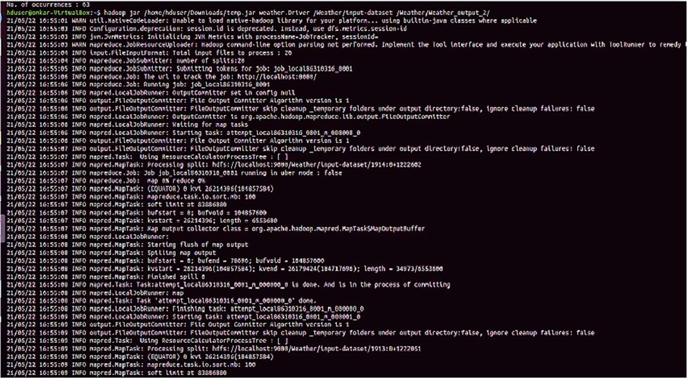

Conclusion: Thus program using mareduce is implemented.

**Title:**

### ASSIGNMENT NO: 4

Perform the following operations using Python on the Facebook metrics data sets

* 1. Create data subsets
  2. Merge Data
  3. Sort Data
  4. Transposing Data
  5. Shape and reshape Data

**Problem Statement:**

Study and perform different operations on dataset.

**Theory:**

What is python?

Python is a popular high-level programming language that was first released in 1991. It was created by Guido van Rossum and is named after the comedy group Monty Python. Python is known for its simplicity, readability, and versatility. It is an interpreted language, which means that code is executed line by line, rather than being compiled all at once.

Python has a large and supportive community, with a vast array of libraries and frameworks that make it useful for a variety of applications, from web development to data analysis and machine learning. Python is often considered an easy language for beginners to learn, but it is also a powerful language that is used by many professional developers and organizations.

**Code & output:**

**Problem Statement**

Perform the following operations using Python on the Facebook metrics data sets

1. Create data subsets
2. Merge Data
3. Sort Data
4. Transposing Data
5. Shape and reshape Data

#### Importing Libraries

In [ 1]: **import** numpy **as np**

**import** pandas **as pd**

#### Importing the dataset

In [3]: data= pd.read_csv('Datasets/dataset_Facebook.csv',sep=';') data.head()

Out[3]:

**Page total likes**

**Type Category**

**Post Post Post Month Weekday Hour**

**Paid**

**Lifetime**

**Post Total Reach**

|  |  |  |
| --- | --- | --- |
| **Lifetime** | **Lifetime** | **L** |
| **Post Total** | **Engaged** |  |
| **Impressions** | **Users** | **Con** |

|  |  |  |  |  |  |  |  |  |  |  |  |  |
| --- | --- | --- | --- | --- | --- | --- | --- | --- | --- | --- | --- | --- |
|  | **0** | 139441 | Photo | 2 | 12 | 4 | 3 | 0.0 | 2752 | 5091 | 178 |  |
| **1** | 139441 | Status | 2 | 12 | 3 | 10 | 0.0 | 10460 | 19057 | 1457 |  |
| **2** | 139441 | Photo | 3 | 12 | 3 | 3 | 0.0 | 2413 | 4373 | 177 |  |
| **3** | 139441 | Photo | 2 | 12 | 2 | 10 | 1.0 | 50128 | 87991 | 2211 |  |
| ◄ | **4** | 139441 | Photo | 2 | 12 | 2 | 3 | 0.0 | 7244 | 13594 | 671 | ► |

In [4]: *#Describing the data*

data.describe()

Out [ 4]:

**Page total Category likes**

**Post Month**

**Post Post Hour Paid Weekday**

**Lifetime Post Total**

**Reach**

|  |  |  |  |  |  |  |  |
| --- | --- | --- | --- | --- | --- | --- | --- |
| **count** | 500.000000 | 500.000000 | 500.000000 | 500.000000 | 500.000000 | 499.000000 | 500.00000 |
| **mean** | 123194.176000 | 1.880000 | 7.038000 | 4.150000 | 7.840000 | 0.278557 | 13903.36000 |
| **std** | 16272.813214 | 0.852675 | 3.307936 | 2.030701 | 4.368589 | 0.448739 | 22740.78789 |
| **min** | 81370.000000 | 1.000000 | 1.000000 | 1.000000 | 1.000000 | 0.000000 | 238.00000 |
| **25%** | 112676.000000 | 1.000000 | 4.000000 | 2.000000 | 3.000000 | 0.000000 | 3315.00000 |
| **50%** | 129600.000000 | 2.000000 | 7.000000 | 4.000000 | 9.000000 | 0.000000 | 5281.00000 |
| **75%** | 136393.000000 | 3.000000 | 10.000000 | 6.000000 | 11.000000 | 1.000000 | 13168.00000 |
| **max** | 139441.000000 | 3.000000 | 12.000000 | 7.000000 | 23.000000 | 1.000000 | 180480.00000 |

◄ ►

##### Creating Subsets

In [14]: subset1 = data[['Page total likes', 'Category', 'Post Month', 'Post Weekday']].loc[0:: 15]

subsetl

|  |  |  |  |  |
| --- | --- | --- | --- | --- |
| Out [14]: | **Page total likes** | **Category** | **Post Month** | **Post Weekday** |
|  | **0** 139441 | 2 | 12 | 4 |
|  | **1** 139441 | 2 | 12 | 3 |
|  | **2** 139441 | 3 | 12 | 3 |
|  | **3** 139441 | 2 | 12 | 2 |
|  | **4** 139441 | 2 | 12 | 2 |
|  | **5** 139441 | 2 | 12 |  |
|  | **6** 139441 | 3 | 12 |  |
|  | **7** 139441 | 3 | 12 | 7 |
|  | **8** 139441 | 2 | 12 | 7 |
|  | **9** 139441 | 3 | 12 | 6 |
|  | **10** 139441 | 2 | 12 | 5 |
|  | **11** 139441 | 2 | 12 | 5 |
|  | **12** 139441 | 2 | 12 | 5 |
|  | **13** 139441 | 2 | 12 | 5 |
|  | **14** 138414 | 2 | 12 | 4 |
|  | **15** 138414 | 2 | 12 | 3 |

In [15]:

subset2 = data[['Page total likes', 'Category', 'Post Month', 'Post Weekday']].loc[16 :: 30]

subset2

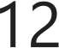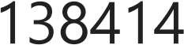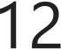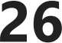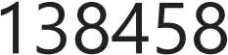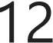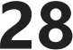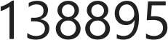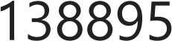

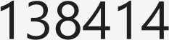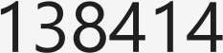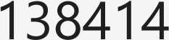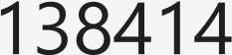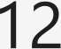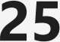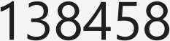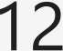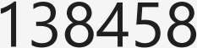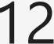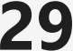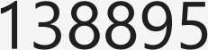



subset3 = data[['Page total likes','Category','Post Month','Post Weekday']].loc[31:45] subset3

|  |  |  |  |  |
| --- | --- | --- | --- | --- |
| **31** | 138895 | 2 | 12 | 3 |
| **32** | 138895 | 3 | 12 | 3 |
| **33** | 138895 | 3 | 12 | 2 |
| **34** | 138895 |  | 12 | 2 |
| **35** | 138895 | 2 | 12 |  |
| **36** | 138895 | 3 | 12 |  |
| **37** | 138895 |  | 12 | 7 |
| **38** | 138895 | 2 | 12 | 7 |
| **39** | 138895 |  | 12 | 7 |
| **40** | 138895 | 2 | 12 | 6 |
| **41** | 138895 |  | 12 | 6 |
| **42** | 138353 |  | 12 | 5 |
| **43** | 138353 |  | 12 | 5 |
| **44** | 138353 |  | 12 | 4 |
| **45** | 138353 |  | 12 | 4 |
| **46** | 138353 |  | 12 | 3 |
| **47** | 138353 |  | 12 | 3 |
| **48** | 138353 |  | 12 | 2 |
| **49** | 138353 |  | 12 | 2 |
| **so** | 138353 | 2 | 11 |  |

1. **Merging data**

In [17]: mergedData=pd.concat([subset1,subset2,subset3]) mergedData

|  |  |  |  |  |
| --- | --- | --- | --- | --- |
| Out [17]: | **Page total likes** | **Category** | **Post Month** | **Post Weekday** |
|  | **0** 139441 | 2 | 12 | 4 |
|  | **1** 139441 | 2 | 12 | 3 |
|  | **2** 139441 | 3 | 12 | 3 |
|  | **3** 139441 | 2 | 12 | 2 |
|  | **4** 139441 | 2 | 12 | 2 |
|  | **5** 139441 | 2 | 12 |  |
|  | **6** 139441 | 3 | 12 |  |
|  | **7** 139441 | 3 | 12 | 7 |
|  | **8** 139441 | 2 | 12 | 7 |
|  | **9** 139441 | 3 | 12 | 6 |
|  | **10** 139441 | 2 | 12 | 5 |
|  | **11** 139441 | 2 | 12 | 5 |
|  | **12** 139441 | 2 | 12 | 5 |
|  | **13** 139441 | 2 | 12 | 5 |
|  | **14** 138414 | 2 | 12 | 4 |
|  | **15** 138414 | 2 | 12 | 3 |
|  | **16** 138414 | 3 | 12 | 3 |
|  | **17** 138414 |  | 12 | 2 |
|  | **18** 138414 | 3 | 12 | 2 |
|  | **19** 138414 | 3 | 12 |  |
|  | **20** 138414 | 2 | 12 |  |
|  | **21** 138414 |  | 12 | 7 |
|  | **22** 138414 |  | 12 | 7 |
|  | **23** 138414 | 3 | 12 | 7 |
|  | **24** 138414 | 2 | 12 | 6 |
|  | **25** 138458 | 2 | 12 | 6 |
|  | **26** 138458 | 2 | 12 | 5 |
|  | **27** 138458 | 3 | 12 | 5 |
|  | **28** 138895 | 2 | 12 | 5 |
|  | **29** 138895 |  | 12 | 4 |
|  | **30** 138895 | 2 | 12 | 4 |
|  | **31** 138895 | 2 | 12 | 3 |
|  | **32** 138895 | 3 | 12 | 3 |
|  | **33** 138895 | 3 | 12 | 2 |
|  | **34** 138895 |  | 12 | 2 |
|  | **35** 138895 | 2 | 12 |  |



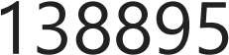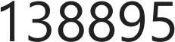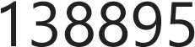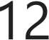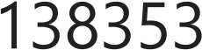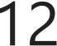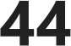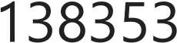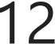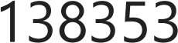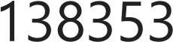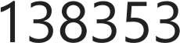

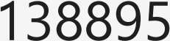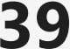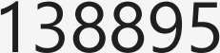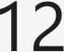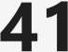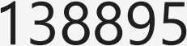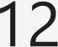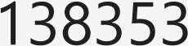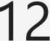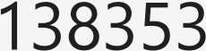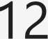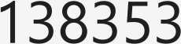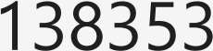





sortedData=data.sort_values('Page total likes', ascending=False) sortedData

Out[19]:

**Page total likes**

**Type Category**

**Post Post Post Month Weekday Hour**

**Paid**

**Lifetime**

**Post Total Reach**

|  |  |  |
| --- | --- | --- |
| **Lifetime** | **Lifetime** |  |
| **Post Total**  **Impressions** | **Engaged**  **Users** | **C,** |

|  |  |  |  |  |  |  |  |  |  |  |
| --- | --- | --- | --- | --- | --- | --- | --- | --- | --- | --- |
| **0** | 139441 | Photo | 2 | 12 | 4 | 3 | 0.0 | 2752 | 5091 | 178 |
| **8** | 139441 | Status | 2 | 12 | 7 | 3 | 0.0 | 11844 | 22538 | 1530 |
| **1** | 139441 | Status | 2 | 12 | 3 | 10 | 0.0 | 10460 | 19057 | 1457 |
| **12** | 139441 | Photo | 2 | 12 | 5 | 10 | 0.0 | 2847 | 5133 | 193 |
| **11** | 139441 | Photo | 2 | 12 | 5 | 10 | 0.0 | 3112 | 5590 | 208 |
| **495** | 85093 | Photo | 3 |  | 7 | 2 | 0.0 | 4684 | 7536 | 733 |
| **496** | 81370 | Photo | 2 |  | 5 | 8 | 0.0 | 3480 | 6229 | 537 |
| **497** | 81370 | Photo |  |  | 5 | 2 | 0.0 | 3778 | 7216 | 625 |
| **498** | 81370 | Photo | 3 |  | 4 | 11 | 0.0 | 4156 | 7564 | 626 |
| **499** | 81370 | Photo | 2 |  | 4 | 4 | NaN | 4188 | 7292 | 564 |

500 rows x 19 columns

◄ ►

##### Transposing data

In [20]: transposedData=data.transpose() transposedData

Out[20]:

**likes**

|  |  |  |  |  |  |  |  |  |  |
| --- | --- | --- | --- | --- | --- | --- | --- | --- | --- |
| **0** | **1** | **2** | **3** | **4** | **5** | **6** | **7** | **8** | **9** |
| **Page total** 139441 | 139441 | 139441 | 139441 | 139441 | 139441 | 139441 | 139441 | 139441 | 139441 |
| **Type** Photo | Status | Photo | Photo | Photo | Status | Photo | Photo | Status | Photo |
| **Category** 2 | 2 | 3 | 2 | 2 | 2 | 3 | 3 | 2 | 3 |
| **Post Month** 12 | 12 | 12 | 12 | 12 | 12 | 12 | 12 | 12 | 12 |
| **Post Weekday** 4 | 3 | 3 | 2 | 2 |  |  | 7 | 7 | 6 |
| **Post Hour** 3 | 10 | 3 | 10 | 3 | 9 | 3 | 9 | 3 | 10 |
| **Paid** 0.0 | 0.0 | 0.0 | 1.0 | 0.0 | 0.0 | 1.0 | 1.0 | 0.0 | 0.0 |
| **Lifetime Post** 2752 | 10460 | 2413 | 50128 | 7244 | 10472 | 11692 | 13720 | 11844 | 4694 |
| **Lifetime Post**  **Total** 5091 | 19057 | 4373 | 87991 | 13594 | 20849 | 19479 | 24137 | 22538 | 8668 |
| **Impressions** |  |  |  |  |  |  |  |  |  |
| **Lifetime**  **Engaged** 178 | 1457 | 177 | 2211 | 671 | 1191 | 481 | 537 | 1530 | 280 |
| **Users** |  |  |  |  |  |  |  |  |  |
| **Lifetime Post** 109 | 1361 | 113 | 790 | 410 | 1073 | 265 | 232 | 1407 | 183 |
| **Lifetime Post** 159 | 1674 | 154 | 1119 | 580 | 1389 | 364 | 305 | 1692 | 250 |
| **Lifetime Post** |  |  |  |  |  |  |  |  |  |
| **Impressions** |  |  |  |  |  |  |  |  |  |
| **by people** 3078 | 11710 | 2812 | 61027 | 6228 | 16034 | 15432 | 19728 | 15220 | 4309 |
| **liked your** |  |  |  |  |  |  |  |  |  |
| **Page** |  |  |  |  |  |  |  |  |  |
| **Lifetime Post** |  |  |  |  |  |  |  |  |  |
| **reach by** 1640 | 6112 | 1503 | 32048 | 3200 | 7852 | 9328 | 11056 | 7912 | 2324 |
| **like your Page** |  |  |  |  |  |  |  |  |  |
| **Lifetime** |  |  |  |  |  |  |  |  |  |
| **People who** |  |  |  |  |  |  |  |  |  |
| **have liked** 119 | 1108 | 132 | 1386 | 396 | 1016 | 379 | 422 | 1250 | 199 |
| **engaged with** |  |  |  |  |  |  |  |  |  |
| **your post** |  |  |  |  |  |  |  |  |  |
| **comment** 4 | 5 | 0 | 58 | 19 |  | 3 | 0 | 0 | 3 |
| **like** 79.0 | 130.0 | 66.0 | 1572.0 | 325.0 | 152.0 | 249.0 | 325.0 | 161.0 | 113.0 |
| **share** 17.0 | 29.0 | 14.0 | 147.0 | 49.0 | 33.0 | 27.0 | 14.0 | 31.0 | 26.0 |
| **Total** 100 | 164 | 80 | 1777 | 393 | 186 | 279 | 339 | 192 | 142 |

**Total Reach**

**Consumers**

**Consumptions**

**who have**

**people who**

**your Page and**

**Interactions**

19 rows x 500 columns

◄ ►

#### Shape and reshape data





nrows=data.shape[0] ncols=data.shape[l]

print(f'The dataset consists of {nrows} rows and {ncols} columns.')



# *Reshaping*

pivotTable = pd.pivot_table(data,index=['Type','Category'],values='comment') pivotTable

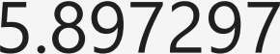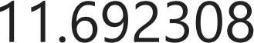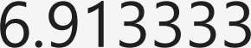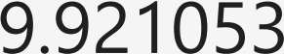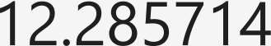

# *Reshaping an array*

array= np.arange(l,11) reshapedArray = array.reshape(5,2) reshapedArray



**Title:**

### ASSIGNMENT NO: 5

Perform the following operations using Python on the Air quality and Heart Diseases data sets

1. Data cleaning
2. Data integration
3. Data transformation
4. Error correcting
5. Data model building

**Problem Statement:**

Study and perform different operations on dataset.

**Theory**:

Data Cleaning is the process of detecting and correcting (or removing) corrupt or inaccurate records from a record set, table, or database and refers to identifying incomplete, incorrect, inaccurate or irrelevant parts of the data and then replacing, modifying, or deleting the dirty or coarse data.

Data Transformation:

Stages of Predictive Modeling

Predictive Modeling is the process of building a model to predict future outcomes using statistics techniques. In order to generate the model, historical data of prior occurrences needs to be analyzed, classified and validated.

Listed below are the stages of predictive modeling:

1. Data Gathering and Cleansing
2. Data Analysis/Transformation
3. Building a Predictive Model
4. Inferences

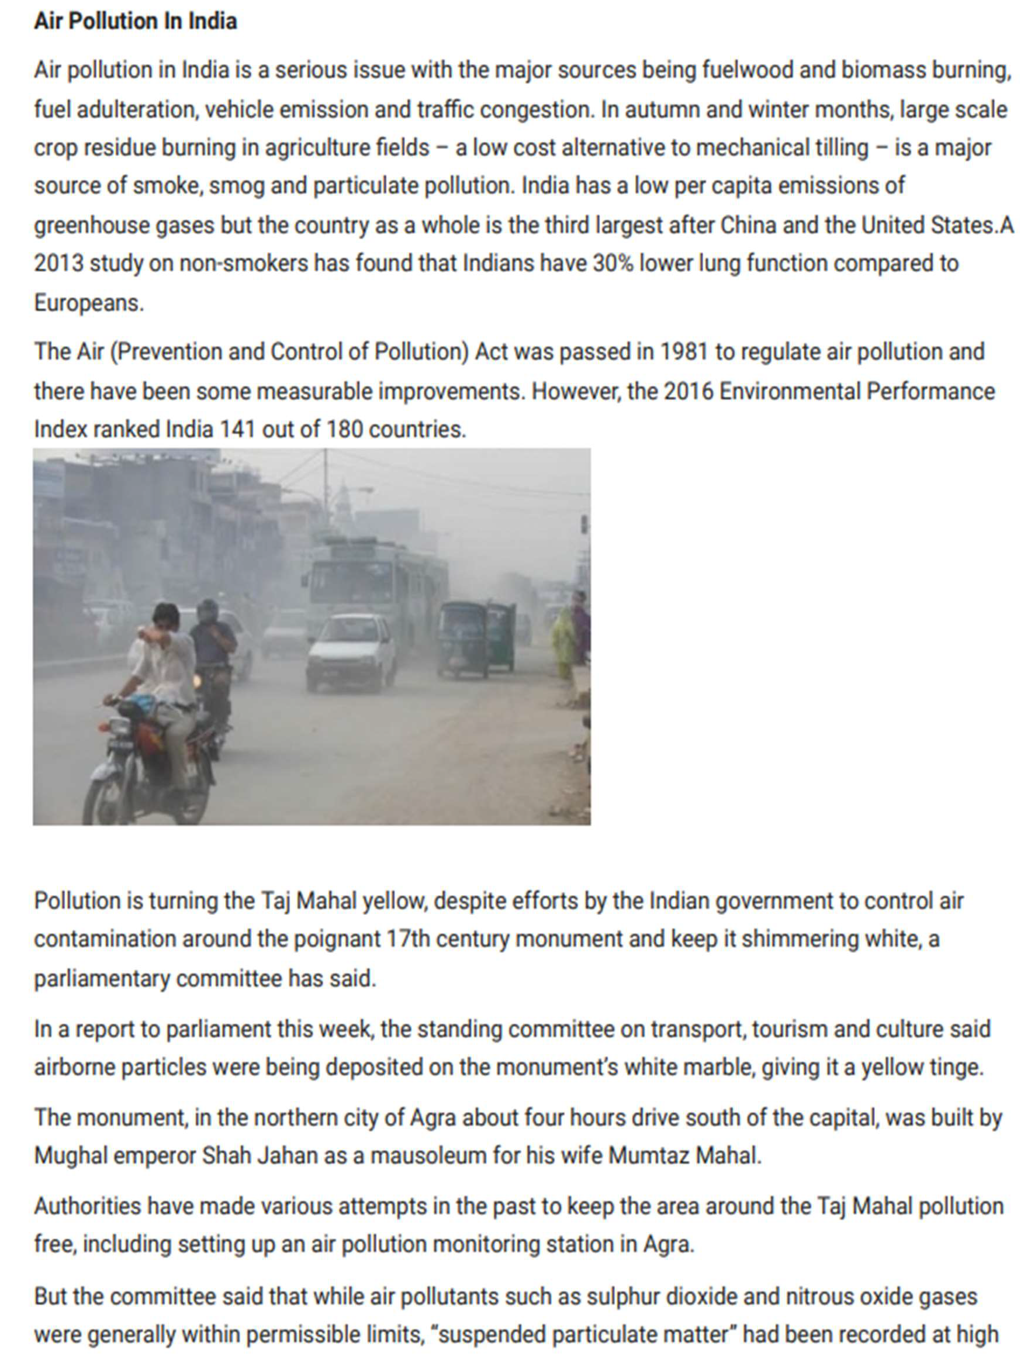

**Code & output:**



*#Importing Libraries* **import** numpy **as** np **import** pandas **as** pd

**import** matplotlib.pyplot **as** plt

**import** seaborn **as** sns

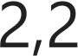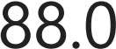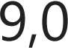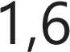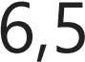

*#Loading csv file on a dataframe*

ar = pd.read_csv('Datasets/AirQuality.csv',sep=';') ar.head()

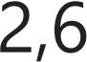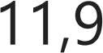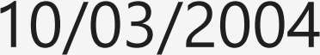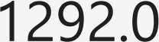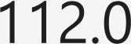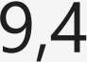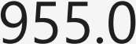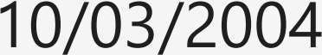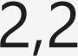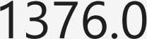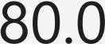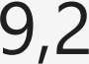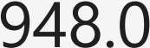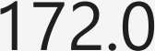

◄ ►





ar.info()



*#Dropping CO(GT) and Unnamed columns*

ar.drop(['CO(GT)','Unnamed: 15','Unnamed: 16'],axis = 1,inplace = **True)**

*#Formatting some object columns from strings to floats*

ar.replace(to_replace=',',value='.',regex=True,inplace=True)

**for i in** 'C6H6(GT) T RH AH'.split():

ar[i] = pd.to_numeric(ar[i],errors='coerce')





*#Replacing null data from* -200 to *NaN for posterior treatment*

ar.replace(to_replace=-200,value=np.nan,inplace=True) ar.info()





*#Formatting Date and Time* to *datetime type*

ar['Date'] = pd.to_datetime(ar['Date'],dayfirst=True)

ar['Time'] = pd.to_datetime(ar['Time'],format= '%H.%M.%S' ).dt.time ar.head()

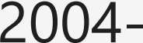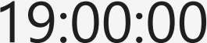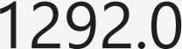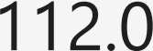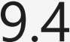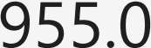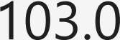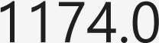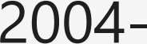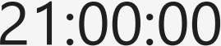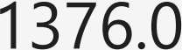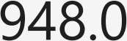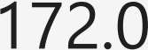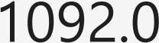

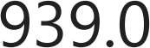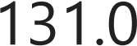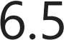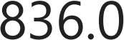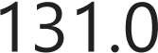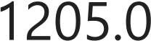◄ ►





NMHC ratio= ar['NMHC(GT)'].isna().sum()/len(ar['NMHC(GT)'])

print('The NMHC(GT) sensor has {:.2f}% of missing data.'.format(NMHC_ratio*100))

*#Removing NMHC(GT) sensor due* to *amount of null values*

ar.drop('NMHC(GT)', axis=l, inplace=True)

ar.info()

<class 'pandas.core.frame.DataFrame'> Rangeindex: 9471 entries, 0 to 9470 Data columns (total 13 columns):

# Column Non-Null Count Dtype

* 1. Date 9357 non-null datetime64[ns]
  2. Time 9357 non-null object
  3. PT08.Sl(CO) 8991 non-null float64
  4. C6H6(GT) 8991 non-null float64
  5. PT08.S2(NMHC) 8991 non-null float64
  6. NOx(GT) 7718 non-null float64
  7. PT08.S3(NOx) 8991 non-null float64
  8. NO2(GT) 7715 non-null float64
  9. PT08.S4(NO2) 8991 non-null float64
  10. PT08.S5(O3) 8991 non-null float64
  11. T 8991 non-null float64
  12. RH 8991 non-null float64
  13. AH 8991 non-null float64 dtypes: datetime64[ns](l), float64(11), object(l) memory usage: 962.0+ KB

In [11]: sns.set_theme(style="whitegrid")

In [12]: **for** i **in** ar.columns[2:13]:

sns.boxplot(x=ar[i])

plt.title('Boxplot of the sensors data') pH.show()

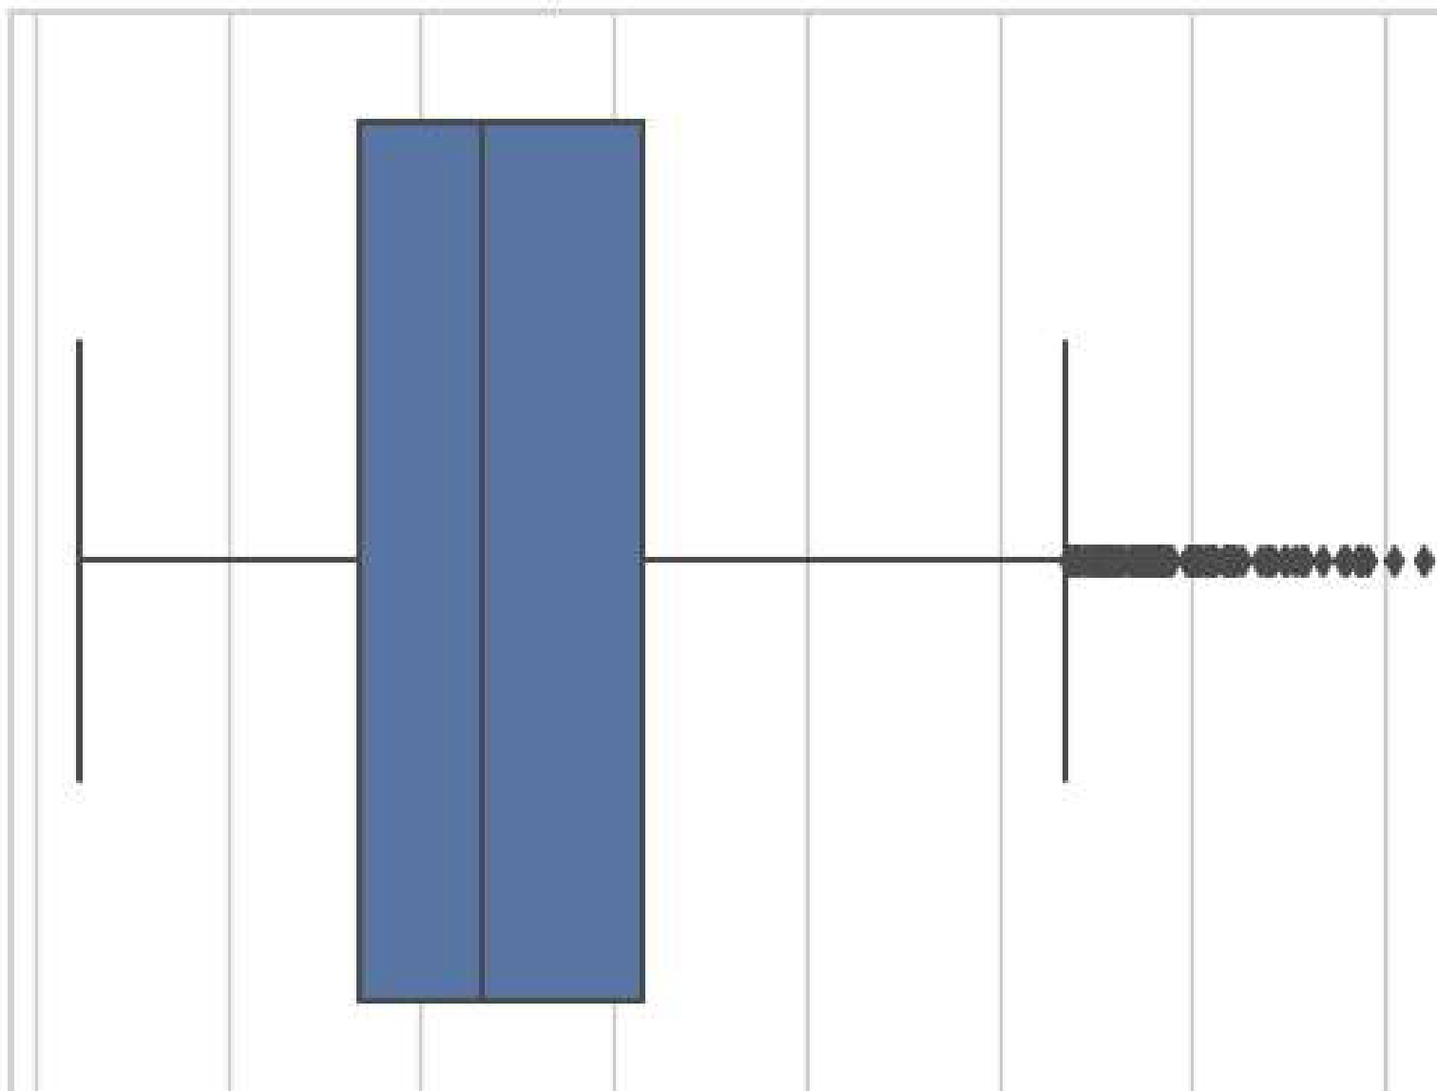Boxp,lol of the sensors data

**600 1000 1200 1400 1600**

PT08_S1(CO)

1800 2000

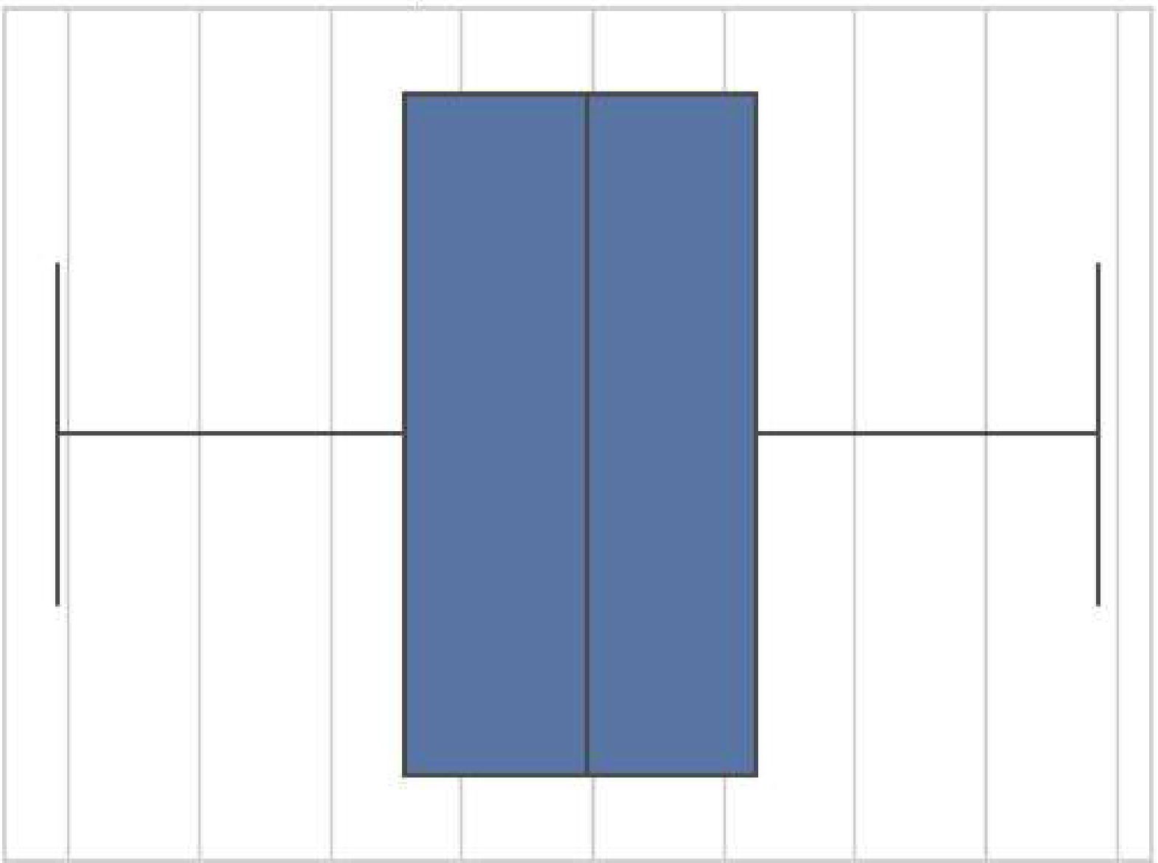**Boxplol of the sensors data**

**10** 20 **30 40 50**

##### RH

60 **70 80 90**

**Boxplol of the sensors data**



- •

**0.5 1.0 1.5 2.0**

Al-I

In [13]: *#Removing Outliers with the Interquartile Range Method (IQR)*

Ql = ar.quantile(0.25) *#first 25% of the data*

Q3 = ar.quantile(0.75) *#first 75% of the data*

!QR= Q3 - Ql *#IQR* = *InterQuartile Range*

scale= 2 *#For Normal Distributions, scale= 1.5*

lower_lim = Ql - scale*IQR upper_lim = Q3 + scale*IQR

lower outliers= (ar[ar.columns[2:13]] < lower_lim) upper_outliers = (ar[ar.columns[2:13]] > upper_lim)

C:\Users\ASUS\AppData\Local\Temp\ipykernel_17060\3919401421.py:3: Futurewarning: T he default value of numeric_only in DataFrame.quantile is deprecated. In a future version, it will default to False. Select only valid columns or specify the value of numeric_only to silence this warning.

Ql = ar.quantile(0.25) #first 25% of the data C:\Users\ASUS\AppData\Local\Temp\ipykernel_17060\3919401421.py:4: Futurewarning: T he default value of numeric_only in DataFrame.quantile is deprecated. In a future version, it will default to False. Select only valid columns or specify the value of numeric_only to silence this warning.

Q3 = ar.quantile(0.75) #first 75% of the data

In [14]: *#Checking the resulting outliers calculated by the above method (represented below*

ar[ar.columns[2:13]][(lower_outliers I upper_outliers)J.info()

<class 'pandas.core.frame.DataFrame'> Rangelndex: 9471 entries, 0 to 9470 Data columns (total 11 columns):

# Column Non-Null Count Dtype

1. PT08.Sl(CO) 30 non-null float64
2. C6H6(GT) 105 non-null float64
3. PT08.S2(NMHC) 13 non-null float64
4. NOx(GT) 244 non-null float64
5. PT08.S3(NOx) 114 non-null float64
6. NO2(GT) 32 non-null float64
7. PT08.S4(NO2) 20 non-null float64
8. PT08.S5(O3) 17 non-null float64
9. T 0 non-null float64
10. RH 0 non-null float64
11. AH 0 non-null float64 dtypes: float64( 11)

memory usage: 814.0 KB

In [15]: *#Create new DataFrame without the outliers*

num_cols = list(ar.columns[2:13])

ar_out_IQR = ar[ ((ar[num_cols] < (Ql - 2 * !QR)) l(ar[num_cols] > (Q3 + 2 * !QR)) ar_out_IQR.info()

<class 'pandas.core.frame.DataFrame'> Int64Index: 9029 entries, 0 to 9470 Data columns (total 13 columns):

# Column Non-Null Count Dtype

|  |  |  |  |  |
| --- | --- | --- | --- | --- |
| 0 | Date | 8915 | non-null | datetime64[ns] |
| 1 | Time | 8915 | non-null | object |
| 2 | PT08.Sl(CO) | 8595 | non-null | float64 |
| 3 | C6H6(GT) | 8595 | non-null | float64 |
| 4 | PT08.S2(NMHC) | 8595 | non-null | float64 |
| 5 | NOx(GT) | 7313 | non-null | float64 |
| 6 | PT08.S3(NOx) | 8595 | non-null | float64 |
| 7 | NO2(GT) | 7310 | non-null | float64 |
| 8 | PT08.S4(NO2) | 8595 | non-null | float64 |
| 9 | PT08.S5(O3) | 8595 | non-null | float64 |
| 10 | T | 8595 | non-null | float64 |
| 11 | RH | 8595 | non-null | float64 |
| 12 | AH | 8595 | non-null | float64 |

dtypes: datetime64[ns](l), float64(11), object(l) memory usage: 987.5+ KB

In [16]: *#Removing NOx(GT) and N02(GT) sensor data due the ammount of null values if compari*

pd.options.mode.chained_assignment = **None** ar_out_IQR.drop(['NOx(GT)','NO2(GT)'],axis=l, inplace=True) ar_out_IQR.info()

<class 'pandas.core.frame.DataFrame'> Int64Index: 9029 entries, 0 to 9470 Data columns (total 11 columns):

# Column Non-Null Count Dtype

|  |  |  |  |
| --- | --- | --- | --- |
| 0 Date | 8915 | non-null | datetime64[ns] |
| 1 Time | 8915 | non-null | object |
| 2 PT08.Sl(CO) | 8595 | non-null | float64 |
| 3 C6H6(GT) | 8595 | non-null | float64 |
| 4 PT08.S2(NMHC) | 8595 | non-null | float64 |
| 5 PT08.S3(NOx) | 8595 | non-null | float64 |
| 6 PT08.S4(NO2) | 8595 | non-null | float64 |
| 7 PT08.S5(O3) | 8595 | non-null | float64 |
| 8 T | 8595 | non-null | float64 |
| 9 RH | 8595 | non-null | float64 |
| 10 AH | 8595 | non-null | float64 |

dtypes: datetime64[ns](l), float64(9), object(l) memory usage: 846.5+ KB

In [17]: *#Eliminating rows with NaN values*

ar_filt = ar_out_IQR.dropna(how='any', axis=0) ar_filt.reset_index(drop=True,inplace=True)

In [18]: ar_filt.info()

<class 'pandas.core.frame.DataFrame'> Rangeindex: 8595 entries, 0 to 8594 Data columns (total 11 columns):

# Column Non-Null Count Dtype

1. Date 8595 non-null datetime64[ns]
2. Time 8595 non-null object
3. PT08.Sl(CO) 8595 non-null float64
4. C6H6(GT) 8595 non-null float64
5. PT08.S2(NMHC) 8595 non-null float64
6. PT08.S3(NOx) 8595 non-null float64
7. PT08.S4(NO2) 8595 non-null float64
8. PT08.S5(O3) 8595 non-null float64
9. T 8595 non-null float64
10. RH 8595 non-null float64
11. AH 8595 non-null float64 dtypes: datetime64[ns](l), float64(9), object(l) memory usage: 738.8+ KB

In [19]: *#Adding a column with the week days*

ar_filt['Week Day'] = ar_filt['Date'].dt.day_name()

*#Rearranging columns*

cols= ar_filt.columns.tolist()

cols= cols[:1] + cols[-1:] + cols[l:11] ar_filt = ar_filt[cols] ar_filt.head(10)

Out[19]:

|  |  |  |  |  |  |  |
| --- | --- | --- | --- | --- | --- | --- |
| **Date Week Day** | **Time** | **PT08.S1(CO)** | **C6H6(GT)** | **PT08.S2(NMHC)** | **PT08.S3(NOx)** | **PT08.S4(t** |
| **0** 2004- Wednesday | 18:00:00 | 1360.0 | 11.9 | 1046.0 | 1056.0 | H |
| **1** 2004- Wednesday | 19:00:00 | 1292.0 | 9.4 | 955.0 | 1174.0 | 1 |
| 2004-  **2** Wednesday | 20:00:00 | 1402.0 | 9.0 | 939.0 | 1140.0 | 1 |
| 2004-  **3** Wednesday | 21:00:00 | 1376.0 | 9.2 | 948.0 | 1092.0 | 1 |
| **4** 2004- Wednesday | 22:00:00 | 1272.0 | 6.5 | 836.0 | 1205.0 | 1, |
| 2004-  5 Wednesday | 23:00:00 | 1197.0 | 4.7 | 750.0 | 1337.0 | 1: |
| **6** 2004- Thursday | 00:00:00 | 1185.0 | 3.6 | 690.0 | 1462.0 | 1: |
| **7** 2004- Thursday | 01:00:00 | 1136.0 | 3.3 | 672.0 | 1453.0 | 1: |
| **8** 2004- Thursday | 02:00:00 | 1094.0 | 2.3 | 609.0 | 1579.0 | 1; |
| 2004-  **9** Thursday | 07:00:00 | 1144.0 | 3.2 | 667.0 | 1490.0 | 1: |

03-10

03-10

03-10

03-10

03-10

03-10

03-11

03-11

03-11

03-11

◄ ►

In **[20]:** *#Creating new dataframe with only wednesday data*

ar_wed = ar_filt[ar_filt['Week Day']== 'Wednesday']

*#Plotting the mean hourly value of CO on Wednesdays*

sns.barplot(x='Time',y='PT08.Sl(CO)', data=ar_wed.sort_values('Time')) plt.title('Mean Hourly Values of CO on Wednesdays') plt.xticks(rotation=90)

pH.show()

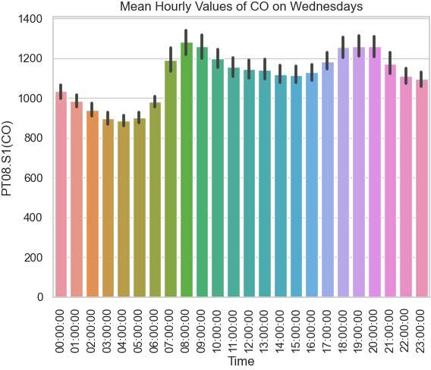

*#The peak concentration of CO in the city are between 8 AM and 9 AM and between 6 I #beginnings and endings of office hours respectively.*

*#Plotting correlation matrix*

sns.heatmap(ar.corr(),annot=True,cmap = 'coolwarm') plt.title('Correlation Matrix')

pH.show()



PT08.S1(CO) 06H6(GT) PT08.82{NMHC)

NO:x(GT)

PT08.S3(NOx)

N02(GT1 PT08..S4(N02} PTOB.S5(03)

T

RH

AH

Correlation Matrix

1..0

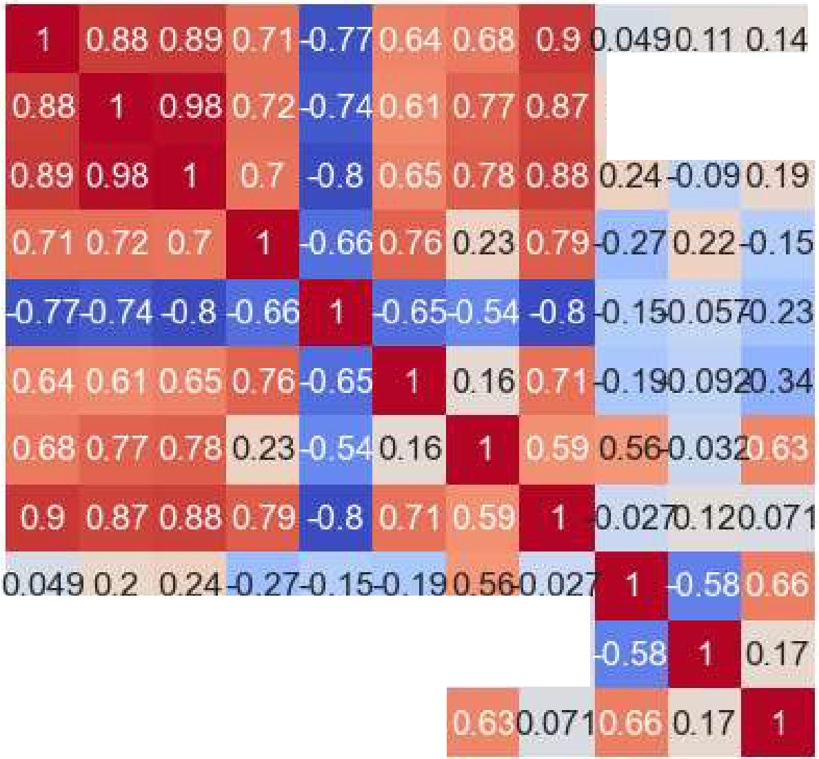

0.2-0,062:)_17

1

Q_11-0.0620.09 0.22-0.0S:ll.09-E.0320.12

0,14 0.17 0,19-0_15-{L23-0.34

-

..u.,.......

00

0

--

I

I-

(9

co

:c

*()*

:::l=

._,

C, 0

z

><:

z

0

X

---

-

CD

I-

C"\I

-

8

z

0

-

O')

I-

LO

C"':l

-,;!'



-

0.8

0.6

0.4

0.2



-

-

-

0.0

*-02*

-0.4

-0.6

a:i B c-r z *r.n*

0z *r.n* co

0 00 cx:i cx:i C

ti: a:i 0 0 t

## 0 ti: ti: ti:

In [23]: sns.pairplot(ar)

plt. show()

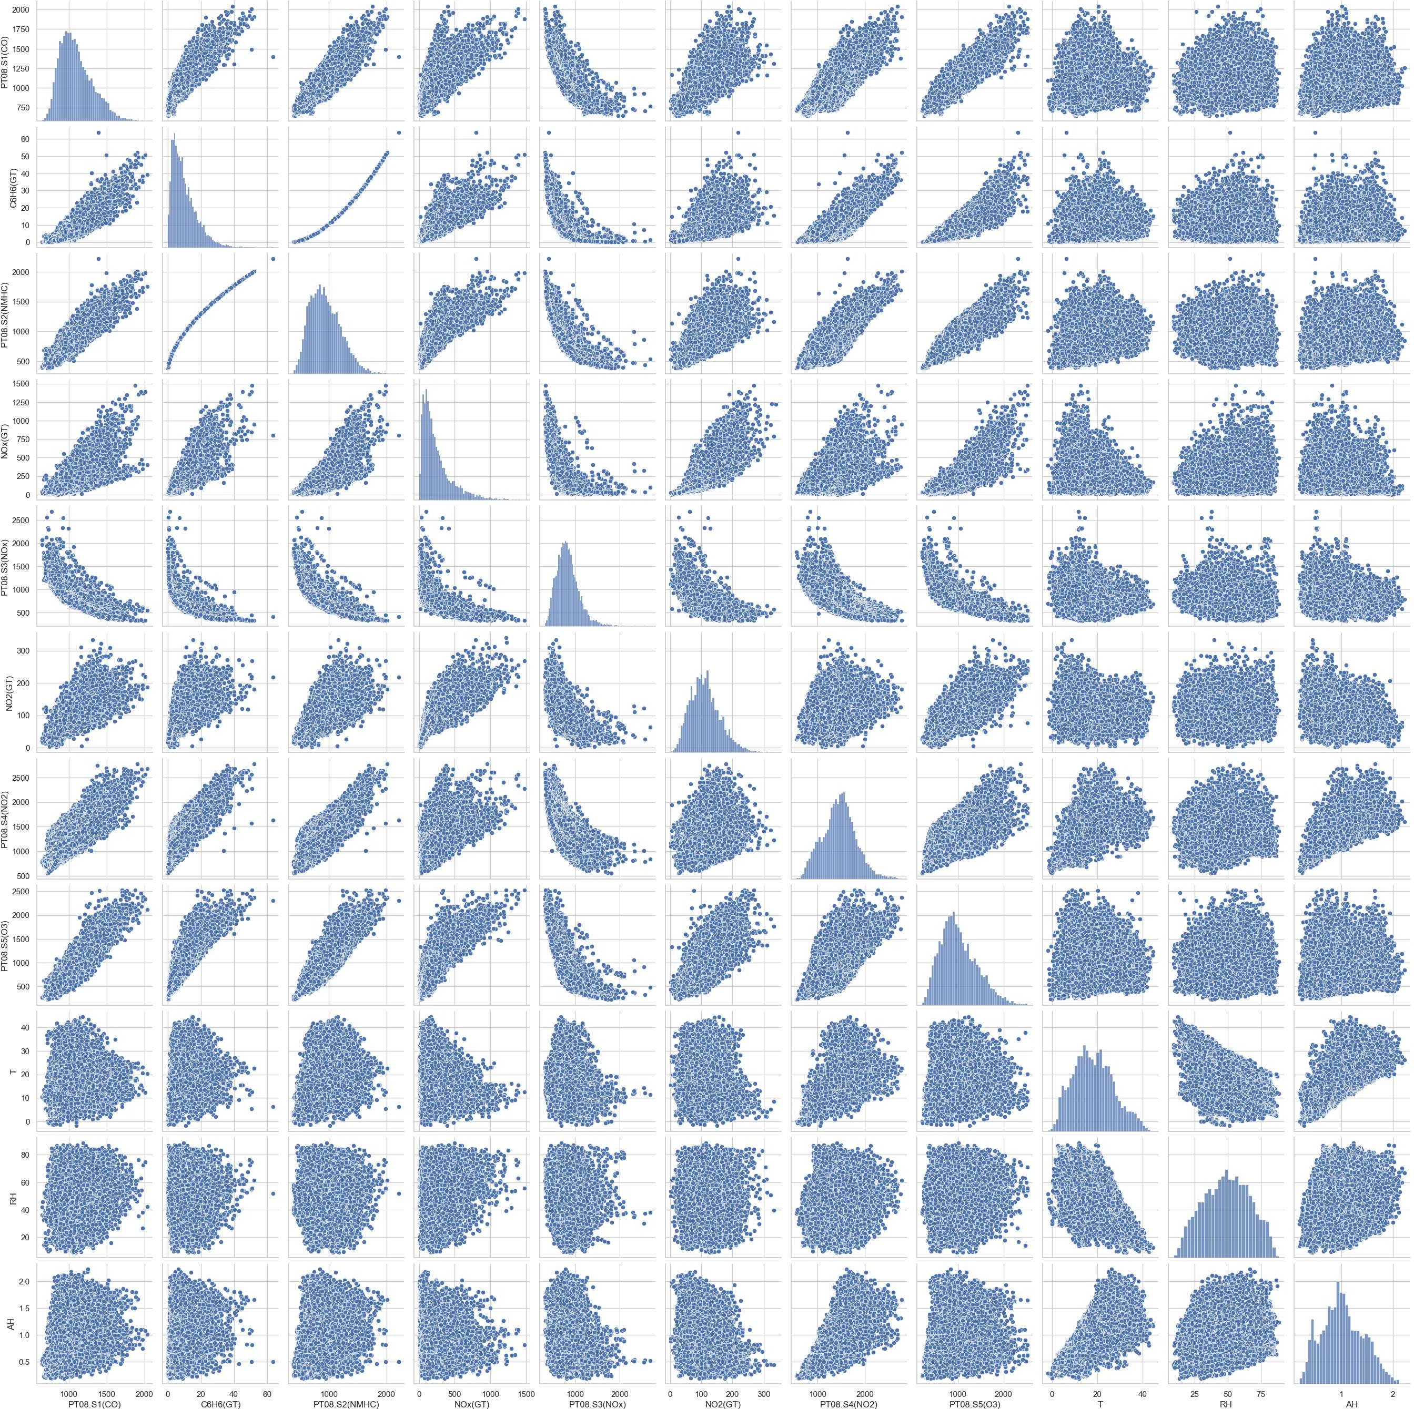



*#Eliminating the C6H6(GT) for being a redundant sensor (the C6HC molecule* is *a Non­ #the correlation between those* two *sensor* is *exact*

ar_filt.drop('C6H6(GT)', axis=l, **inplace=True)**

*#Creating a Regression Model of the PT68.51 sensor:*

*#Splitting the dataset in 86% for training and 26% for testing*

**from** sklearn.model_selection **import** train_test_split Y = ar_filt['PT08.Sl(CO)'] *#varidvel de predirao*

**X** = ar_filt.drop(['PT08.Sl(CO)','Date', 'Time', 'Week Day'], axis=l)

X_train, X_test, Y_train, Y_test = train_test_split(X, Y, test_size=0.2, random st: print(X_train.shape, X_test.shape)

**from** sklearn.ensemble **import** RandomForestRegressor

modelo randomforest = RandomForestRegressor(n_estimators=100) modelo_randomforest.fit(X_train, Y_train)





RandomForestRegressor()

,. RandomForestRegressor



*#Evaluating the results with the R2 metric:*

1

*#Test data evaluation*

**from** sklearn **import** metrics

pred_randomforest = modelo_randomforest.predict(X_test) *#predicted CO concentratio1*

print('Random Forest Regression Model: R2={:.2f}'.format(metrics.r2_score(Y_test,

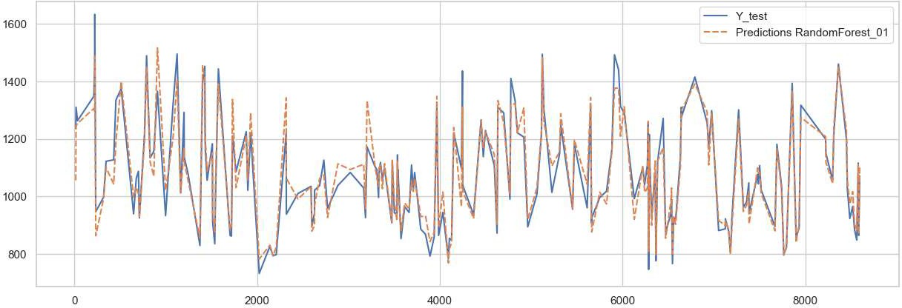

*#Comparing model predictions with the Ground Truth Test Data*

aux= pd.DataFrame()

aux['Y_test'] = Y_test

aux['Predictions RandomForest_01'] = pred_randomforest

plt.figure(figsize=(15,5)) sns.lineplot(data=aux.iloc[:200,:]) pH.show()

*#Extracting season information from Date column:*

**def** season(date):

year= str(date.year)

seasons= {'spring': pd.date_range(start='21/03/'+year, end='20/06/'+year), 'summer': pd.date_range(start='21/06/'+year, end='22/09/'+year), 'autumn': pd.date_range(start='23/09/'+year, end='20/12/'+year)}

**if** date **in** seasons['spring']:

**return** 'spring'

**if** date **in** seasons['summer']:

**return** 'summer'

**if** date **in** seasons['autumn']:

**return** 'autumn'

**else:**

**return** 'winter'

ar_filt['Season'] = ar_filt['Date'].map(season) ar_filt.head(10)

Out[ 32]:

◄

C:\Users\ASUS\AppData\Local\Temp\ipykernel_17060\1681381420.py:5: Userwarning: Par sing dates in DD/MM/VYYY format when dayfirst=False (the default) was specified. T his may lead to inconsistently parsed dates! Specify a format to ensure consistent parsing.

seasons= {'spring': pd.date_range(start='21/03/'+year, end='20/06/'+year), C:\Users\ASUS\AppData\Local\Temp\ipykernel_17060\1681381420.py:6: UserWarning: Par sing dates in DD/MM/VVYY format when dayfirst=False (the default) was specified. T his may lead to inconsistently parsed dates! Specify a format to ensure consistent parsing.

'summer': pd.date_range(start='21/06/'+year, end='22/09/'+year),

C:\Users\ASUS\AppData\Local\Temp\ipykernel_17060\1681381420.py:7: UserWarning: Par sing dates in DD/MM/VYYY format when dayfirst=False (the default) was specified. T his may lead to inconsistently parsed dates! Specify a format to ensure consistent parsing.

'autumn': pd.date_range(start='23/09/'+year, end='20/12/'+year)}

|  |  |  |  |  |  |  |
| --- | --- | --- | --- | --- | --- | --- |
| **Date Week Day** | **Time** | **PT08.S1(CO)** | **PT08.S2(NMHC)** | **PT08.S3(NOx)** | **PT08.S4(NO2)** | **PT08.** |
| **0** 2004- Wednesday | 18:00:00 | 1360.0 | 1046.0 | 1056.0 | 1692.0 |  |
| **1** 2004- Wednesday | 19:00:00 | 1292.0 | 955.0 | 1174.0 | 1559.0 |  |
| **2** 2004- Wednesday | 20:00:00 | 1402.0 | 939.0 | 1140.0 | 1555.0 |  |
| **3** 2004- Wednesday | 21:00:00 | 1376.0 | 948.0 | 1092.0 | 1584.0 |  |
| **4** 2004- Wednesday | 22:00:00 | 1272.0 | 836.0 | 1205.0 | 1490.0 |  |
| **5** 2004- Wednesday | 23:00:00 | 1197.0 | 750.0 | 1337.0 | 1393.0 |  |
| **6** 2004- Thursday | 00:00:00 | 1185.0 | 690.0 | 1462.0 | 1333.0 |  |
| **7** 2004- Thursday | 01:00:00 | 1136.0 | 672.0 | 1453.0 | 1333.0 |  |
| **8** 2004- Thursday | 02:00:00 | 1094.0 | 609.0 | 1579.0 | 1276.0 |  |
| **9** 2004- Thursday | 07:00:00 | 1144.0 | 667.0 | 1490.0 | 1339.0 | ► |

03-10

03-10

03-10

03-10

03-10

03-10

03-11

03-11

03-11

03-11

In [33]: sns.pairplot(ar_filt, hue='Season') plt.show()

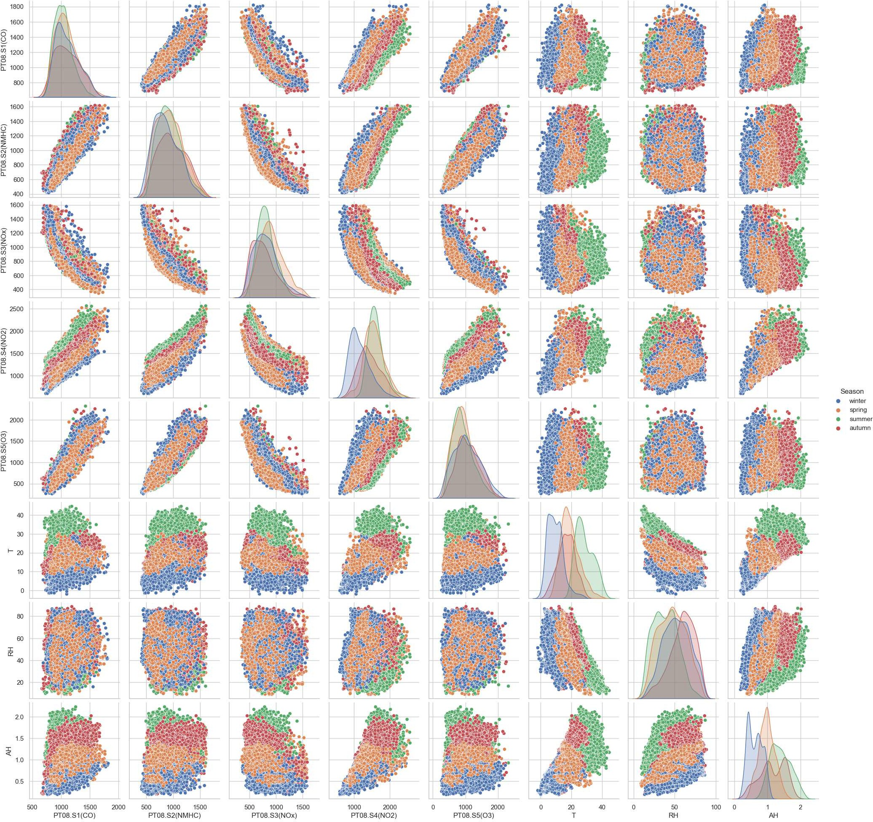

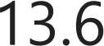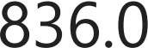

*#Creating categorical features from Season column and splitting new dataframe*

y - 2 = ar_filt['PT08.Sl(CO)']

**X**- 2 = ar_filt.drop(['PT08.Sl(CO)','Date', 'Time', 'Week Day'], axis=l)

**X**- 2 = pd.get_dummies(data=X_2)

X_2_train, X_2_test, Y_2_train, Y_2_test = train_test_split(X_2, Y_2, test_size=0.: X_2.head()

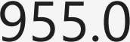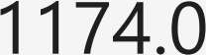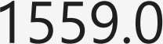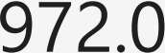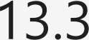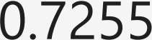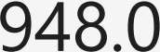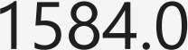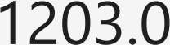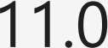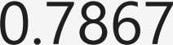

◄ ►





modelo_randomforest_2 = RandomForestRegressor()

modelo_randomforest_2.fit(X_2_train, Y_2_train)





RandomForestRegressor()

,. RandomForestRegressor

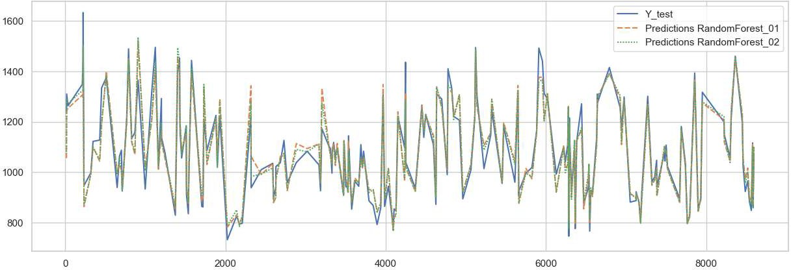

pred_randomforest_2 = modelo_randomforest_2.predict(X_2_test)

print('Regression Model without Seasons: R2={:.2f}'.format(metrics.r2_score(Y_test print('Regression Model with Seasons: R2={:.2f}'.format(metrics.r2_score(Y_2_test,



aux['Predictions RandomForest_02'] = pred_randomforest_2

plt.figure(figsize=(lS,5)) sns.lineplot(data=aux.iloc[:200,:]) plt.show()

*#It can be seen that the new model used the new information to react slightly bett1 #in the predicted variable.*



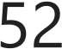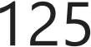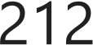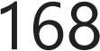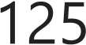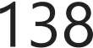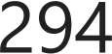



**import** pandas **as** pd **import** numpy as np **import** seaborn **as** sns

**import** matplotlib.pyplot **as** plt

**import** seaborn **as** sns

**import** plotly.express **as px**

data= pd.read_csv('Datasets/heart.csv')

data.head()

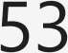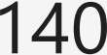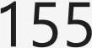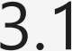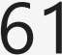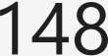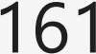

◄ ►



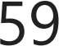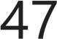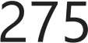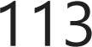

data.tail()

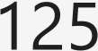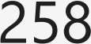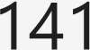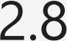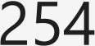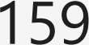

◄ ►

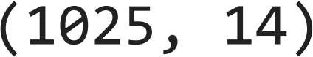

data.shape

data.columns



data.info()

<class 'pandas.core.frame.DataFrame'> Rangeindex: 1025 entries, 0 to 1024 Data columns (total 14 columns):

# Column Non-Null Count Dtype

1. age **1025** non-null int64
2. sex **1025** non-null int64
3. cp **1025** non-null int64
4. trestbps **1025** non-null int64
5. chol **1025** non-null int64
6. fbs **1025** non-null int64
7. restecg **1025** non-null int64
8. thalach **1025** non-null int64
9. exang **1025** non-null int64
10. oldpeak **1025** non-null float64
11. slope **1025** non-null int64
12. ca **1025** non-null int64
13. thal **1025** non-null int64
14. target **1025** non-null int64 dtypes: float64(1), int64(13)

memory usage: 112.2 **KB**

# Data Preprocessing

In [ 8] : data.describe()

|  |  |  |  |  |  |  |  |  |  |
| --- | --- | --- | --- | --- | --- | --- | --- | --- | --- |
|  | Out[8]: |  | **age** | **sex** | **cp** | **trestbps** | **chol** | **fbs** | **restecg** |
|  |  | **count** | 1025.000000 | 1025.000000 | 1025.000000 | 1025.000000 | 1025.00000 | 1025.000000 | 1025.000000 |
|  |  | **mean** | 54.434146 | 0.695610 | 0.942439 | 131.611707 | 246.00000 | 0.149268 | 0.529756 |
|  |  | **std** | 9.072290 | 0.460373 | 1.029641 | 17.516718 | 51.59251 | 0.356527 | 0.527878 |
|  |  | **min** | 29.000000 | 0.000000 | 0.000000 | 94.000000 | 126.00000 | 0.000000 | 0.000000 |
|  |  | **25%** | 48.000000 | 0.000000 | 0.000000 | 120.000000 | 211.00000 | 0.000000 | 0.000000 |
|  |  | **50%** | 56.000000 | 1.000000 | 1.000000 | 130.000000 | 240.00000 | 0.000000 | 1.000000 |
|  |  | **75%** | 61.000000 | 1.000000 | 2.000000 | 140.000000 | 275.00000 | 0.000000 | 1.000000 |
|  |  | **max** | 77.000000 | 1.000000 | 3.000000 | 200.000000 | 564.00000 | 1.000000 | 2.000000 |
| ◄ |  |  |  |  |  |  |  |  | ► |

**Checking for null value**

In [9]: data.isnull().sum()

Out[9]: age 0

sex 0

cp 0

trestbps 0

chol 0

fbs 0

restecg 0

thalach 0

exang 0

oldpeak 0

slope 0

ca 0

thal 0

target 0

dtype: int64

**Checking duplicate value**

In [10]: # *Check duplicate values*

duplicate_rows = data[data.duplicated()]

duplicate_sort = duplicate_rows.sort_values(by=['age']) print(duplicate_sort)

|  |  |  |  |  |  |  |  |  |
| --- | --- | --- | --- | --- | --- | --- | --- | --- |
|  | age sex cp trestbps | chol | fbs | restecg | thalach | exang | oldpeak | \ |
| 118 | 29 1 1 130 | 204 | 0 | 0 | 202 | 0 | 0.0 |  |
| 64 | 29 1 1 130 | 204 | 0 | 0 | 202 | 0 | 0.0 |  |
| 668 | 29 1 1 130 | 204 | 0 | 0 | 202 | 0 | 0.0 |  |
| 15 | 34 0 1 118 | 210 | 0 | 1 | 192 | 0 | 0.7 |  |
| 779 | 34 0 1 118 | 210 | 0 | 1 | 192 | 0 | 0.7 |  |
| 724 | 74 0 1 120 | 269 | 0 | 0 | 121 | 1 | 0.2 |  |
| 535 | 76 0 2 140 | 197 | 0 | 2 | 116 | 0 | 1.1 |  |
| 965 | 76 0 2 140 | 197 | 0 | 2 | 116 | 0 | 1.1 |  |
| 162 | 77 1 0 125 | 304 | 0 | 0 | 162 | 1 | 0.0 |  |
| 387 | 77 1 0 125 | 304 | 0 | 0 | 162 | 1 | 0.0 |  |
| 118 | slope ca thal target  2 0 2 1 |  |  |  |  |  |  |  |
| 64 | 2 0 2 1 |  |  |  |  |  |  |  |
| 668 | 2 0 2 1 |  |  |  |  |  |  |  |
| 15 | 2 0 2 1 |  |  |  |  |  |  |  |
| 779 | 2 0 2 1 |  |  |  |  |  |  |  |
| 724 | 2 1 2 1 |  |  |  |  |  |  |  |
| 535 | 1 0 2 1 |  |  |  |  |  |  |  |
| 965 | 1 0 2 1 |  |  |  |  |  |  |  |
| 162 | 2 3 2 0 |  |  |  |  |  |  |  |
| 387 | 2 3 2 0 |  |  |  |  |  |  |  |
| [723 | rows x 14 columns] |  |  |  |  |  |  |  |

In [11]: data.duplicated().sum()

Out[11]: 723

**Checking outliers**

In [12]: *#trestbps outliers*

plt.figure(figsize=(10,3)) sns.boxplot(data['trestbps'])

Out[12]: <Axes: >

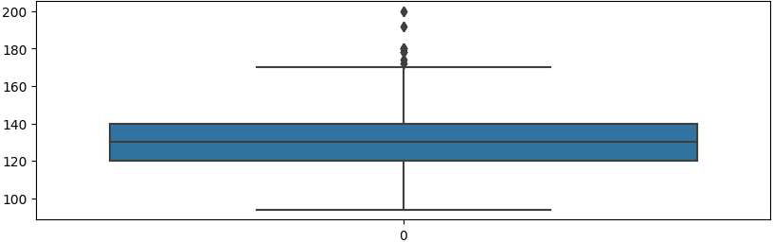

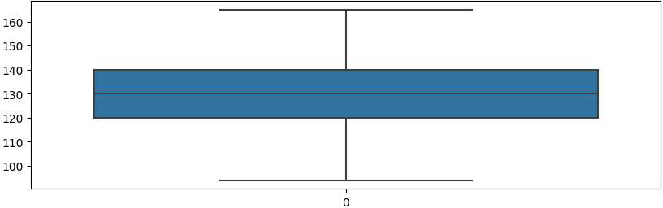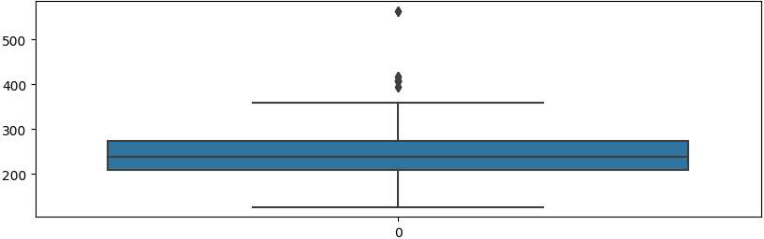

ql = data['trestbps'J.quantile(0.25) q3 = data['trestbps'J.quantile(0.75)

IQR = q3 - ql

lower_limit = ql - 1.5 * !QR upper_limit = q3 + 1.5 * !QR

data= data[(data['trestbps'] > lower_limit) & (data['trestbps'] < upper_limit)] plt.figure(figsize=(10,3))

sns.boxplot(data['trestbps'])

*#chol* plt.figure(figsize=(10,3)) sns.boxplot(data['chol'])

ql = data['chol'J.quantile(0.25) q3 = data['chol'J.quantile(0.75)

!QR= q3 - ql

lower_limit = ql - 1.5 * !QR upper_limit = q3 + 1.5 * !QR

data= data[(data['chol'] > lower_limit) & (data['chol'] < upper_limit)] plt.figure(figsize=(10,3))

sns.boxplot(data['chol'])

6



•

5

4

3

2

1

0

0

In [19]:

Out[19]:

ql = data['oldpeak'],quantile(0.25) q3 = data['oldpeak'],quantile(0.75)

IQR = q3 - ql

lower_limit = ql - 1.5 * IQR upper_limit = q3 + 1.5 * IQR

data= data[(data['oldpeak'] > lower_limit) & (data['oldpeak'] < upper_limit)] plt.figure(figsize=(10,3))

sns.boxplot(data['oldpeak'])

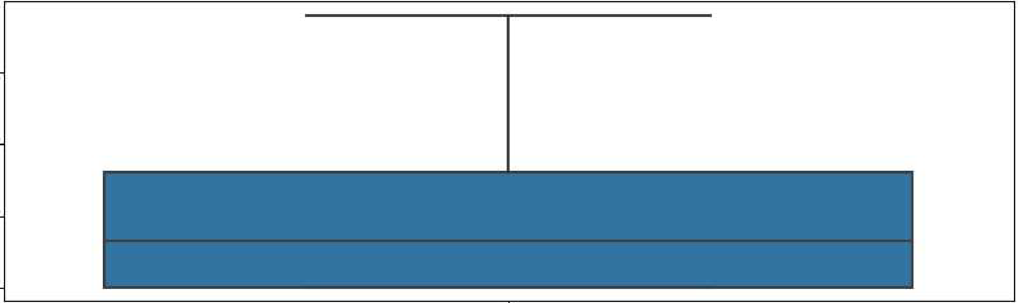<Axes: >

3

2

1

0

0

In [20]:

Out[20]:

plt.figure(figsize=(15,6)) sns.boxplot(data=data, orient='h')

<Axes: >

age sex cp

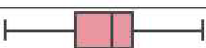

I

**D**

I

I

**i-**

I

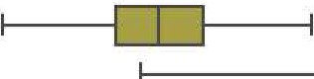

**trestbps**

chol lbs **restecg**

**tnalach exang oldpeak slope**

ca

thal

**target**

0 50 100 150 200 250 300 350

In [21]: # *Checking for balanced dataset*

data['target'].value_counts()

!

Out[21]: 504

438

Name: target, dtype: int64





*#Heatmap Correlation*

**import** seaborn **as** sns

*#Setup the matplotlib figure*

f, ax= plt.subplots(figsize=(30, 25)) corr= data.corr()

matt= data.corr()

mask= np.zeros_like(corr, dtype=np.bool)

# *Generate a custom diverging colormap*

cmap = sns.diverging_palette(230,20, as_cmap=True)

# *Draw the heatmap with the mask and correct aspect ratio*

sns.heatmap(matt, mask=mask,cmap=cmap, vmax=l, center=0, annot **=True,**

square=True, linewidths=.7, cbar_kws={"shrink": .5}) plt.xticks(rotation=90, fontsize=15)

plt.yticks(fontsize=15) plt.show()



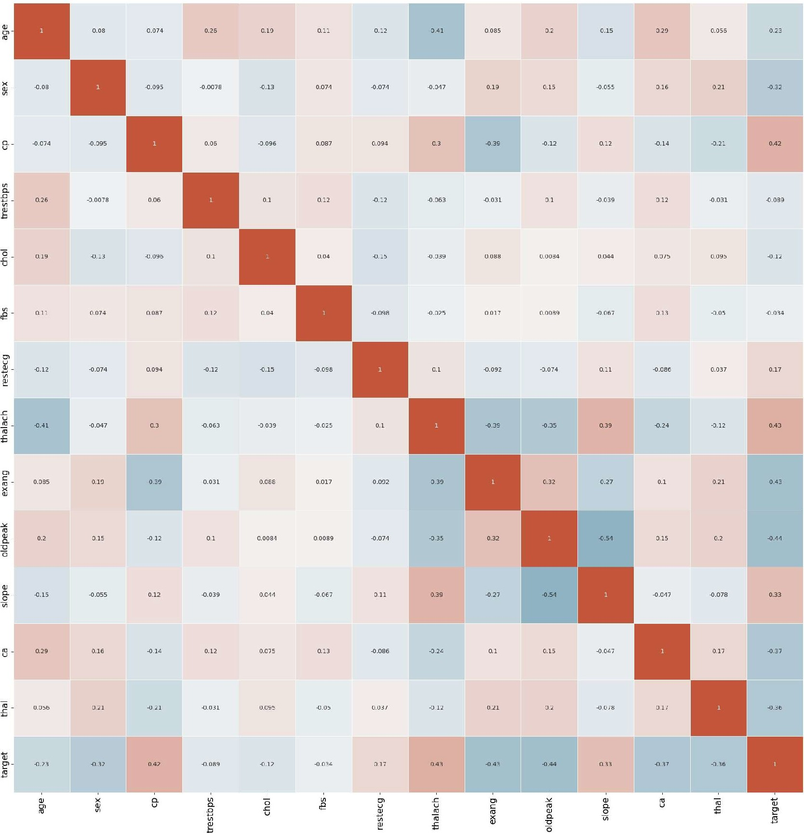

In [23]: # *slope vs target (plt.scatter(X,Y))*

sns.lmplot(data=data, x="slope", y="target")

0ut[23]: <seaborn.axisgrid.FacetGrid at 0x1ffe63fa4d0>

1.0

•

•

•

•

•

•

0.8

0.6



().4

0.2

0.0

0.00 0.25, 0.50 0.75, 1.00 1.-25 1.50 1.75 2.00

slope

In [24]: # *thalach vs target (plt.scatter(X,Y))*

sns.lmplot(data=data, x="thalach", y="target")

Out[24]: <seaborn.axisgrid.FacetGrid at 0xlffe84424d0>

**1.0**

**0.8**

**0.6**



**0.4**

0.2

**0.0**

• • • •

• • • •

**0.0 0.5 1.0** 1.5 **2.0** 2.5 3.0

**cp**

In [27]:

0ut[27]:

sns.pairplot(data=data, hue="target")

<seaborn.axisgrid.PairGrid at 0xlffe8a3e350>

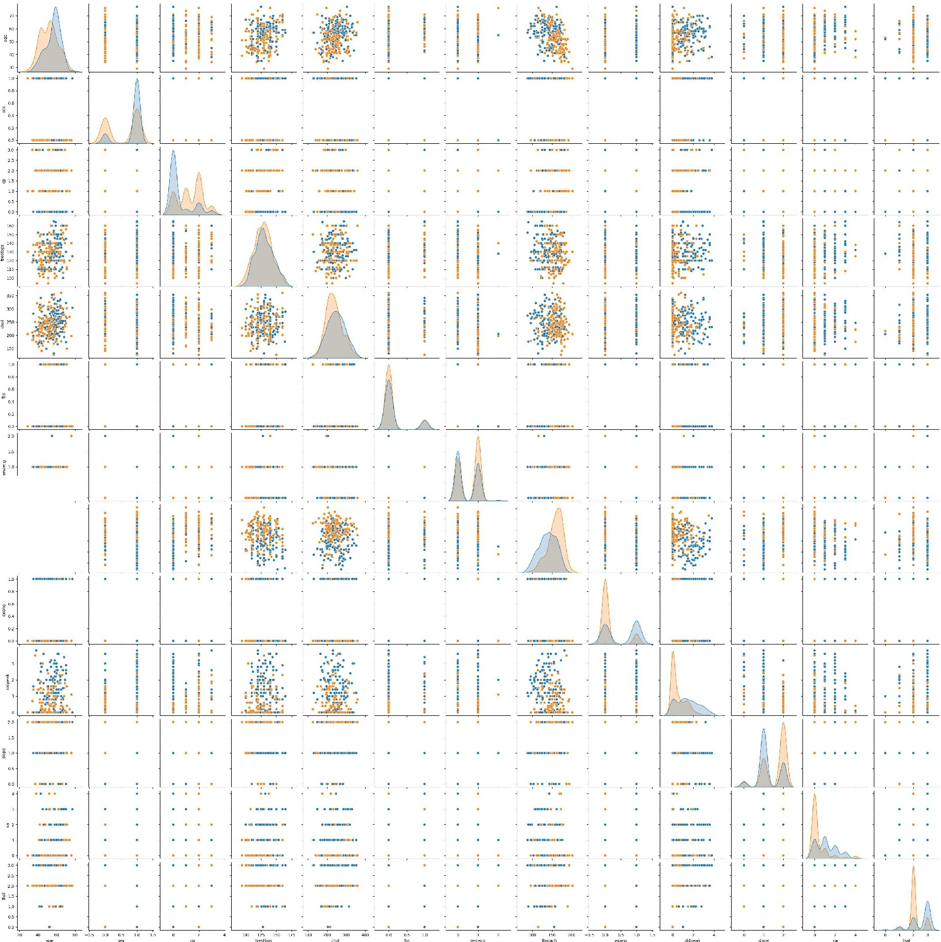

l: . . ..

ClO •,o..;. ••

.,z

In [28]: x=data.drop('target',axis=l)

**X**

|  |  |  |  |  |  |  |  |  |  |  |  |  |  |
| --- | --- | --- | --- | --- | --- | --- | --- | --- | --- | --- | --- | --- | --- |
| Out[28]: | **age** | **sex** | **cp** | **trestbps** | **chol** | **fbs** | **restecg** | **thalach** | **exang** | **oldpeak** | **slope** | **ca** | **thal** |
|  | **0** 52 |  | 0 | 125 | 212 | 0 |  | 168 | 0 | 1.0 | 2 | 2 | 3 |
|  | **1** 53 |  | 0 | 140 | 203 |  | 0 | 155 |  | 3.1 | 0 | 0 | 3 |
|  | **2** 70 |  | 0 | 145 | 174 | 0 |  | 125 |  | 2.6 | 0 | 0 | 3 |
|  | **3** 61 |  | 0 | 148 | 203 | 0 |  | 161 | 0 | 0.0 | 2 |  | 3 |
|  | **4** 62 | 0 | 0 | 138 | 294 |  |  | 106 | 0 | 1.9 |  | 3 | 2 |
|  | **1020** 59 |  |  | 140 | 221 | 0 |  | 164 |  | 0.0 | 2 | 0 | 2 |
|  | **1021** 60 |  | 0 | 125 | 258 | 0 | 0 | 141 |  | 2.8 |  |  | 3 |
|  | **1022** 47 |  | 0 | 110 | 275 | 0 | 0 | 118 |  | 1.0 |  |  | 2 |
|  | **1023** 50 | 0 | 0 | 110 | 254 | 0 | 0 | 159 | 0 | 0.0 | 2 | 0 | 2 |
|  | **1024** 54 |  | 0 | 120 | 188 | 0 |  | 113 | 0 | 1.4 |  |  | 3 |

942 rows x 13 columns

In [29]: y=data['target']

y

Out[29]: 0

0

2 0

3 0

4 0

**1020** 1

1021 0

**1022** 0

**1023** 1

**1024** 0

Name: target, Length: 942, dtype: int64

In [ ]:

# Univariate Selection For categorical Variable

In [30]: **from** sklearn.feature_selection **import** SelectKBest **from** sklearn.feature_selection **import** chi2 bestfeatures = SelectKBest(score_func=chi2)

In [31]: fit= bestfeatures.fit(x,y) scores= pd.DataFrame(fit.scores_)

In [32]: dfcolumns = pd.DataFrame(x.columns)

In [33]: featureScores = pd.concat([dfcolumns,scores],axis=l) featureScores.columns = ['Label','Score']

In [34]: featureScores.sort_values(by='Score',ascending=False)

|  |  |  |  |
| --- | --- | --- | --- |
| Out[ 34]: |  | **Label** | **Score** |
|  | **7** | thalach | 601.806705 |
|  | **9** | oldpeak | 193.196121 |
|  | **11** | ca | 180.353925 |
|  | **2** | cp | 179.716870 |
|  | **8** | exang | 117.508421 |
|  | **4** | chol | 115.677722 |
|  | **0** | age | 75.723136 |
|  | **1** | sex | 28.526796 |
|  | **10** | slope | 25.345451 |
|  | **12** | thal | 19.464820 |
|  | **6** | restecg | 12.709173 |
|  | **3** | trestbps | 12.349684 |
|  | **5** | fbs | 0.963264 |







new_sex=pd.get_dummies(data=data['sex'],prefix='sex') new sex





new_cp=pd.get_dummies(data['cp'],prefix='chestPain') new_cp







new_exang=pd.get_dummies(data['exang'],prefix='exang') new_exang

  



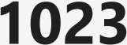





new_slope=pd.get_dummies(data['slope'],prefix='slope') new_slope







new_thal=pd.get_dummies(data['thal'],prefix='thal') new **thal**

    



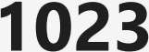





new_ca=pd.get_dummies(data['ca'],prefix='ca') new ca







app=[data,new_sex,new_cp,new_ca,new_thal,new_exang,new_slope]

dfl=pd.concat(app,axis=l)

dfl.head()

|  |  |  |  |  |  |  |  |  |  |  |  |  |
| --- | --- | --- | --- | --- | --- | --- | --- | --- | --- | --- | --- | --- |
| Out [ 43]: | **age** | **sex** | **cp** | **trestbps** | **chol** | **fbs** | **restecg** | **thalach** | **exang** | **oldpeak ca_4** | **thal_0** | **thaI_1** |
|  | **0** 52 |  | 0 | 125 | 212 | 0 |  | 168 | 0 | 1.0 ... 0 | 0 | 0 |
|  | **1** 53 |  | 0 | 140 | 203 |  | 0 | 155 |  | 3.1 ... 0 | 0 | 0 |
|  | **2** 70 |  | 0 | 145 | 174 | 0 |  | 125 |  | 2.6 ... 0 | 0 | 0 |
|  | **3** 61 |  | 0 | 148 | 203 | 0 |  | 161 | 0 | 0.0 ... 0 | 0 | 0 |
|  | **4** 62 | 0 | 0 | 138 | 294 |  |  | 106 | 0 | 1.9 ... 0 | 0 | 0 |

5 rows x 34 columns

◄  ►

In [ 44]: dfl. drop( ['sex', 'cp', 'thal', 'exang', 'ca', 'slope'], axis=1, inplace=True)

**Feature Scalling**

In [45]: **from** sklearn.preprocessing **import** StandardScaler sc=StandardScaler()

In [46]: df1[[ 'age', 'trestbps', 'chol', 'old peak', 'thalach']] =sc. fit_transform ( dfl [ ['age', 'tr1 In [47]: X=df1.drop('target' ,axis=1)

**X**

|  |  |  |  |  |  |  |  |  |  |  |
| --- | --- | --- | --- | --- | --- | --- | --- | --- | --- | --- |
| Out[47]: | **age** | **trestbps** | **chol** | **fbs** | **restecg** | **thalach** | **oldpeak** | **sex_0** | **sex_1** | **chestPain_** |
|  | **0** -0.210426 | -0.290753 | -0.664118 | 0 |  | 0.803573 | 0.046685 | 0 |  |  |
|  | **1** -0.101573 | 0.736589 | -0.864245 |  | 0 | 0.235871 | 2.122016 | 0 |  |  |
|  | **2** 1.748925 | 1.079036 | -1.509101 | 0 |  | -1.074213 | 1.627890 | 0 |  |  |
|  | **3** 0.769250 | 1.284505 | -0.864245 | 0 |  | 0.497887 | -0.941568 | 0 |  |  |
|  | **4** 0.878103 | 0.599610 | 1.159267 |  |  | -1.903932 | 0.936113 |  | 0 |  |
|  | **1020** 0.551544 | 0.736589 | -0.463990 | 0 |  | 0.628896 | -0.941568 | 0 |  |  |
|  | **1021** 0.660397 | -0.290753 | 0.358757 | 0 | 0 | -0.375502 | 1.825540 | 0 |  |  |
|  | **1022** -0.754690 | -1.318095 | 0.736775 | 0 | 0 | -1.379899 | 0.046685 | 0 |  |  |
|  | **1023** -0.428131 | -1.318095 | 0.269811 | 0 | 0 | 0.410548 | -0.941568 |  | 0 |  |
|  | **1024** 0.007280 | -0.633200 | -1.197791 | 0 |  | -1.598246 | 0.441986 | 0 |  |  |

942 rows x 27 columns

◄ ►

In [ 48]: Y=dfl ['target']

V







scaler= StandardScaler() scaler.fit(X)

X_scaled = scaler.transform(X)

**from** sklearn.model_selection **import** train_test_split

*#X_train, X_test, y_train, y_test* = *train_test_split(X_scaled, y, random_state=0)*

X_train, X_test, y_train, y_test = train_test_split(X_scaled, y, test size= 0.2, 1

print(X_train.shape, X_test.shape, y_train.shape, y_test.shape)





*#Logistic Regression*

**from** sklearn.datasets **import** load_iris

**from** sklearn.model_selection **import** cross_val_score,KFold **from** sklearn.linear_model **import** LogisticRegression iris=load_iris()

X=X train Y=y_train

logreg=LogisticRegression() kf=KFold(n_splits=S) score=cross_val_score(logreg,X,Y,cv=kf)

print("Cross Validation Scores are {}".format(score)) print("Average Cross Validation score :{}".format(score.mean()))



*#DecisionTree*

**from** sklearn **import** datasets

**from** sklearn.tree **import** DecisionTreeClassifier

**from** sklearn.model_selection **import** KFold, cross_val_score

*#X, y* = *datasets.Load_iris(return_X_y=True)* elf= DecisionTreeClassifier(random_state=42) k_folds = KFold(n_splits = 5)

scores= cross_val_score(clf, X_train, y_train, cv = k_folds) print("Cross Validation Scores: ", scores)

print("Average CV Score:", scores.mean())

print("Number of CV Scores used in Average: ", len(scores))







*#Logistic Regression*

**from** sklearn.linear_model **import** LogisticRegression

logreg = LogisticRegression() logreg.fit(X_train,y_train)

print("Logistic Regression train score : {:.4f}".format( logreg.score(X_train, y_tr; print("Logistic Regression test score : {:.4f}".format(logreg.score(X_test, y_test



*#Decision Tree*

**from** sklearn.tree **import** DecisionTreeClassifier

tree= DecisionTreeClassifier(max_depth=8, random_state=0) tree.fit(X_train, y_train)

print("Decision Tree train score : {:.4f}".format(tree.score(X_train, y_train))) print("Decision Tree test score : {:.4f}".format(tree.score(X_test, y_test)))





print("Logistic Regression test score : {:.4f}".format(logreg.score(X_test, y_test print("Decision Tree test score {:.4f}".format(tree.score(X_test, y_test)))



pred_logreg = logreg.predict(X_test) pred_tree = tree.predict(X_test)

**from** sklearn.metrics **import** confusion_matrix

cm_logreg = confusion_matrix(y_test, pred_logreg) cm tree= confusion_matrix(y_test, pred_tree)

plt.subplot(l,5,2) plt.title("Logistic Regression")

sns.heatmap(cm_logreg, **annot=True,** cmap="Reds", fmt="d", **cbar=False,** annot_kws={"s:

plt.subplot(l,5,5) plt.title("Decision Tree")

sns.heatmap(cm_tree, **annot=True,** cmap="Reds", fmt="d", **cbar=False,** annot_kws={"siz1

pH.show()

#### logistic Regression Dec.ision*Tree*

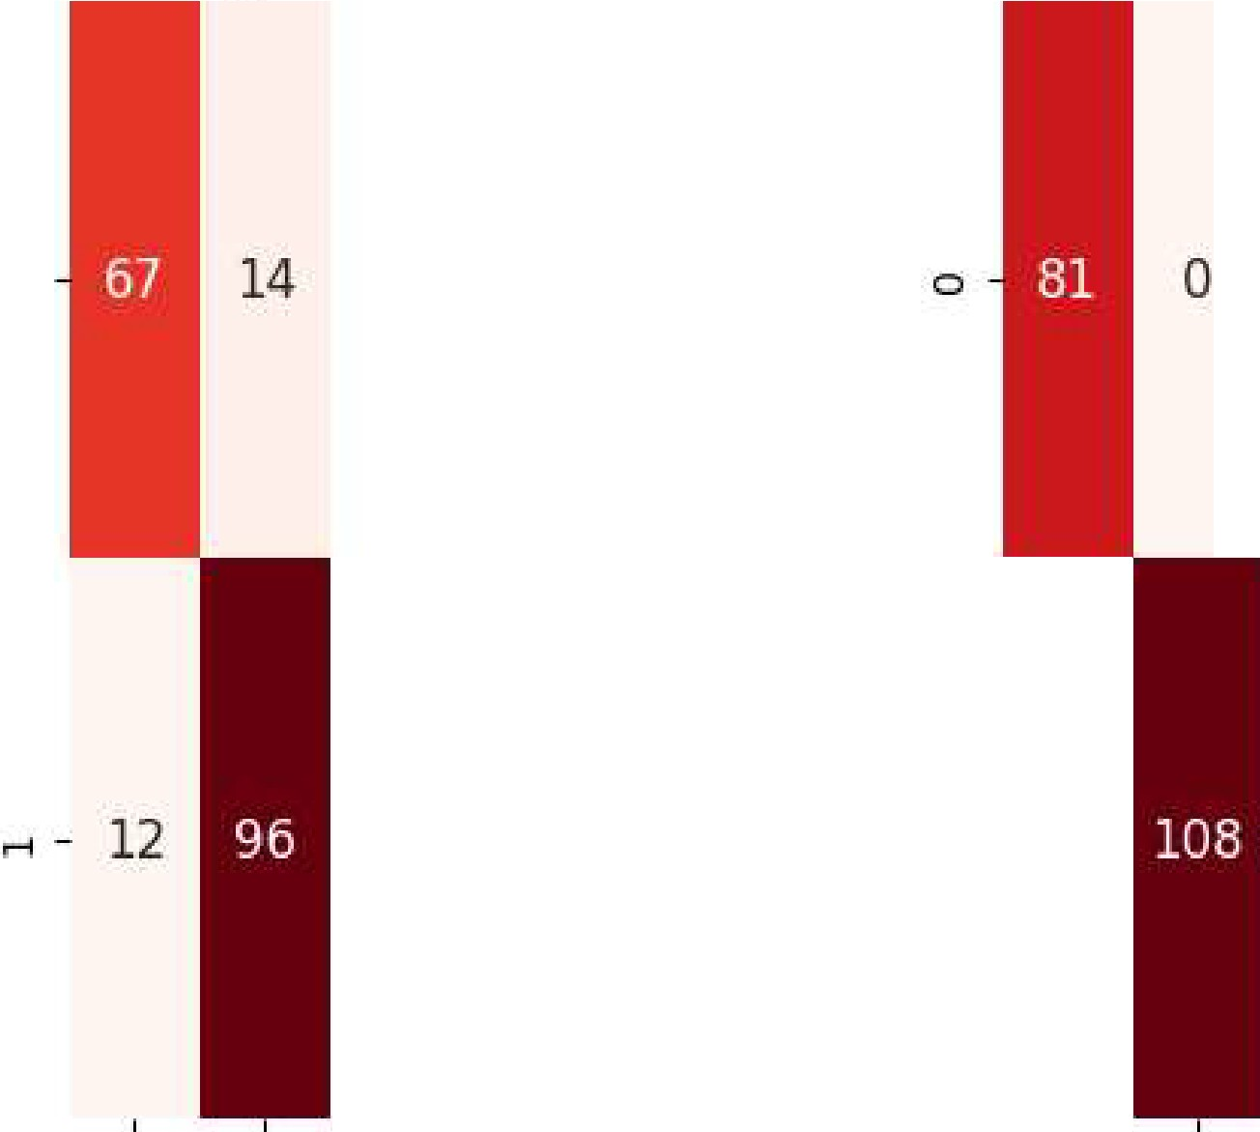

r--1 - **0**

**0**

**0** 1 **0** 1

In [59]: **from** sklearn.metrics **import** classification_report

print(' print('

\n\nlogis· ')

print(classification_report(y_test, pred_logreg, target_names=["Have Disease", "Doi

print(' print('

\n\nDecis: ')

print(classification_report(y_test, pred_tree, target_names=["Have Disease", "Don'·

|  |  |  |  |  |
| --- | --- | --- | --- | --- |
| Logistic Regression | precision | recall | fl-score | support |
| Have Disease | 0.85 | 0.83 | 0.84 | 81 |
| Don't have Disease | 0.87 | 0.89 | 0.88 | 108 |
| accuracy |  |  | 0.86 | 189 |
| macro avg | 0.86 | 0.86 | 0.86 | 189 |
| weighted avg | 0.86 | 0.86 | 0.86 | 189 |

|  |  |  |  |  |
| --- | --- | --- | --- | --- |
| Decision Tree |  | | | |
|  | precision | recall | fl-score | support |
| Have Disease | 1.00 | 1.00 | 1.00 | 81 |
| Don't have Disease | 1.00 | 1.00 | 1.00 | 108 |
| accuracy |  |  | 1.00 | 189 |
| macro avg | 1.00 | 1.00 | 1.00 | 189 |
| weighted avg | 1.00 | 1.00 | 1.00 | 189 |

**Title:**

### ASSIGNMENT NO: 7

Visualize the data using Python libraries matplotlib, seaborn by plotting the graphs**Problem**

**Theory:**

1. Matplotlib: Matplotlib is a comprehensive library for creating static, animated, and interactive visualizations in Python. It provides a wide range of plotting functions and features, allowing users to create line plots, scatter plots, bar plots, histograms, 3D plots, and much more. Matplotlib provides a highly customizable interface, giving users control over various aspects of their plots, such as colors, labels, annotations, and axes. It is widely used in scientific computing, data analysis, and data visualization domains.
2. Seaborn: Seaborn is a Python data visualization library built on top of Matplotlib. It provides a high-level interface and simplifies the creation of attractive statistical graphics. Seaborn enhances Matplotlib's capabilities by providing additional plot types and themes, making it easier to create visually appealing plots with fewer lines of code. Seaborn includes functions for creating statistical visualizations like scatter plots, box plots, violin plots, heatmaps, and regression plots. It also provides tools for handling categorical data and integrating with Pandas data structures.

Both Matplotlib and Seaborn are widely used in the data science community and can be used together to create rich and informative visualizations. They offer a variety of customization options and support for different plot types, making them valuable tools for exploring and communicating data.

**Code & output:**

In [ ] : **import** seaborn **as** sns

**import** matplotlib.pyplot **as** plt

**import** pandas **as** pd

datasetl = pd.read_csv("Datasets/heart.csv")

dataset2 = pd.read_csv("Datasets/AirQuality.csv", sep="; ")

In [18]: datasetl. head()

|  |  |  |  |  |  |  |  |  |  |  |  |  |  |  |  |  |  |  |
| --- | --- | --- | --- | --- | --- | --- | --- | --- | --- | --- | --- | --- | --- | --- | --- | --- | --- | --- |
|  | Out[18]: | **age** | **sex** | **cp** | **trestbps** | | **chol** | **fbs** | **restecg** | **thalach** | **exang** | | **oldpeak** | | **slope** | **ca** | **thal** | **target** |
|  | **0** 52 |  | 0 | 125 | | 212 | 0 |  | 168 | 0 | | 1.0 | | 2 | 2 | 3 | 0 |
|  | **1** 53 |  | 0 | 140 | | 203 |  | 0 | 155 |  | | 3.1 | | 0 | 0 | 3 | 0 |
|  | **2** 70 |  | 0 | 145 | | 174 | 0 |  | 125 |  | | 2.6 | | 0 | 0 | 3 | 0 |
|  | **3** 61 |  | 0 | 148 | | 203 | 0 |  | 161 | 0 | | 0.0 | | 2 |  | 3 | 0 |
|  | **4** 62 | 0 | 0 | 138 | | 294 |  |  | 106 | 0 | | 1.9 | |  | 3 | 2 | 0 |
| ◄ |  |  |  |  |  | |  |  |  |  |  | |  | |  |  |  | ► |
| In [19]: dataset2. head() | | | | | | | | | | | | | | | | | | |
| Out[19]: | | **Date** | | **Time** | | **CO(GT)** | | **PT08.S1(CO)** | | **NMHC(GT)** | | **C6H6(GT)** | | **PT08.S2(NMHC)** | | | | **NOx(GT)** |
|  | | **0** 10/03/2004 | | 18.00.00 | | 2,6 | | 1360.0 | | 150.0 | | 11,9 | | 1046.0 | | | | 166.0 |
|  | | **1** 10/03/2004 | | 19.00.00 | | 2 | | 1292.0 | | 112.0 | | 9,4 | | 955.0 | | | | 103.0 |
|  | | **2** 10/03/2004 | | 20.00.00 | | 2,2 | | 1402.0 | | 88.0 | | 9,0 | | 939.0 | | | | 131.0 |
|  | | **3** 10/03/2004 | | 21.00.00 | | 2,2 | | 1376.0 | | 80.0 | | 9,2 | | 948.0 | | | | 172.0 |
|  | | **4** 10/03/2004 | | 22.00.00 | | 1,6 | | 1272.0 | | 51.0 | | 6,5 | | 836.0 | | | | 131.0 |
| ◄ | |  | |  | |  | |  | |  | |  | |  | | | | ► |

In [4]: sns.pairplot(dataset2) pH.show()

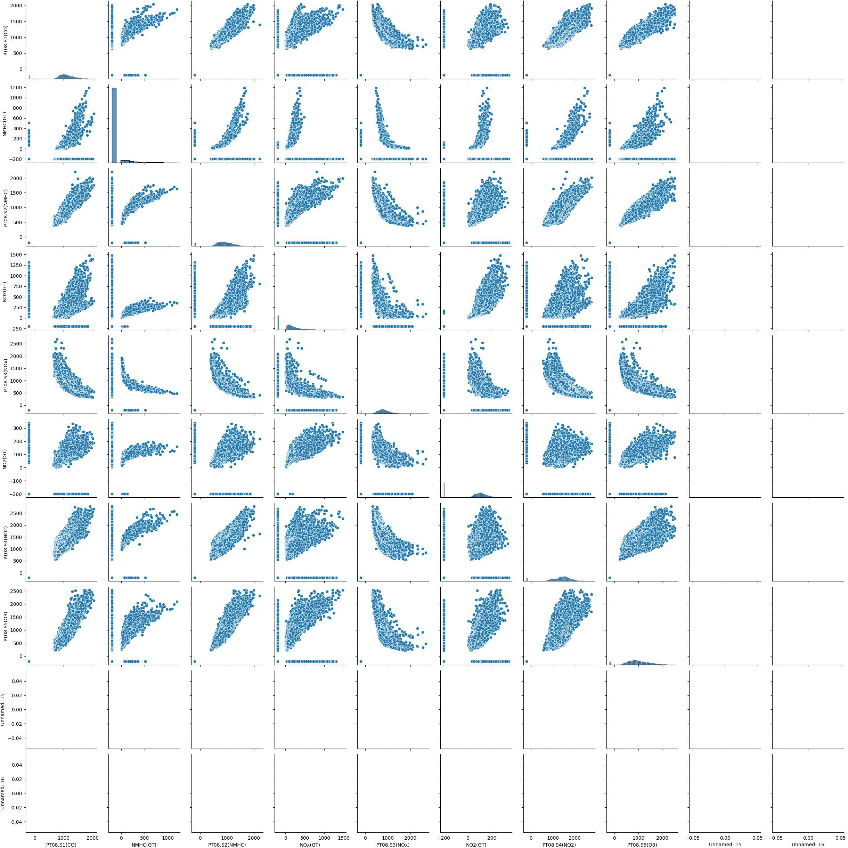



corr= datasetl.corr() # *Compute the correlation matrix*

fig, ax= plt.subplots(figsize=(10, 10)) *#Setup the matplotlib figure*

cmap = sns.diverging_palette(220, 10, as_cmap=True) # *Define a custom colormap*

sns.heatmap(corr, cmap=cmap, center=0, **annot=True,** fmt=".2f'', **square=True,** linewid·

# *Draw the heatmap with the mask and aspect ratio*

plt.yticks(rotation=0) # *Set the y-axis Label* to *be horizontal* plt.title("Correlation Heatmap of Heart Disease Dataset")# *Set the title of the p,* plt.show() # *Show the plot*

1.0

Correlation Heatmap of Heart Disease Dataset

age.-0.10 -0.07 0.27 0.22 0.12 -0.13 -0.3.9 0.09 0.21 -0.17 0.27 0.07 -0.23

■

0.8

sex - -0.10

■

■

cp - -0.117 -0.04

-0.04 -0.08 -0.20 0.03 -0.06 -0.05 0.14 0.08,0.03 0.11 0.20 -0.28



0.114 -Q.08 0.08 0.04 -0.17 0.13 -0.18 -0.16

■

■

trestbps - 0.27 -0.08 0.04

chol - 0.22 -0.20 -0.08 0.13

0.13 0.18 -0.12 -0.04 0.06 0.19 -0.12 0.10 0.06 -0.14

0.03 -0.15 -0.02 0.07 0.06 -0.01 0.07 0.10 -0.10

■

0.6

0.4

tbs - 0.12 0.03 0.08 0.18 0.03

restecg - -0.13 -0.06 0.04 -0.12 -0.15-0.10

-0.10 -0.01 0.05 0.01 -0.06 0.14 -0.04 -0.04

0.05 -0.07 -0.05 0.09 -0.08 -0.02 0.13

■

- 0.2

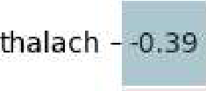-0.05 0.31 -0.04 -0.02 -0.01

0.05

-0.38

-0.21 -0.10

**0.42**



|  |  |  |  |  |  |  |  |  |  |  |
| --- | --- | --- | --- | --- | --- | --- | --- | --- | --- | --- |
| exang - 0.09 | **0.14** |  | **0.06** | 0.07 | 0.05 | -0.07 | -0.38.0.3l | 00.27 | 0.11 0.20 | **-0.44** |
| oldpeak - 0.21 | 0.08 | -0.17 | 0.19 | 0.06 | 0.01 | -0.05 | 0.31 |  | 0.22 0.20 | -0.44 |

slope --0.17 -0.03 0.13 -0.12 -0.01 -0.06 **0.09 -0.27** -0.07 -0.09

■

■

ca - 0.27 0.11 -0.18 0.10 0.07 **0.14** -0.08 -0.21 0.11 **0.22** 00.07

0,15 **-0.38**

**0.35**

- 0.0

- -0,2

thal - 0.07 0.20 -0.16 **0.06** 0.10 -0.04 -0.02 -0.10 0.20 0.20 00,09 0.15

target - -0.23 -0.28 -0.14 -0.10 -0.04 0.13 **0.42 -0.44** -0.44 0.35 -0.,34.

.,,

u cc

-0.34

..,

-0.4

QI 0u. "**C**'**.**

g'

0

..c: **.e**

C, **..c:** 0, QI IC

u u **C:** IC 0. QI

..0., u

.Q.,I "' IC QJ 0

-5 i:'

"Q'J

**"C**

"l!1'

."r:': **C.** "iii .e:i

l:; -' 0

In [9]: sns.boxplot(x='target', y='age', data=datasetl) plt.title('Boxplot of Age by Heart Disease Diagnosis') plt.xlabel('Heart Disease Diagnosis') plt.ylabel('Age')

pH.show()

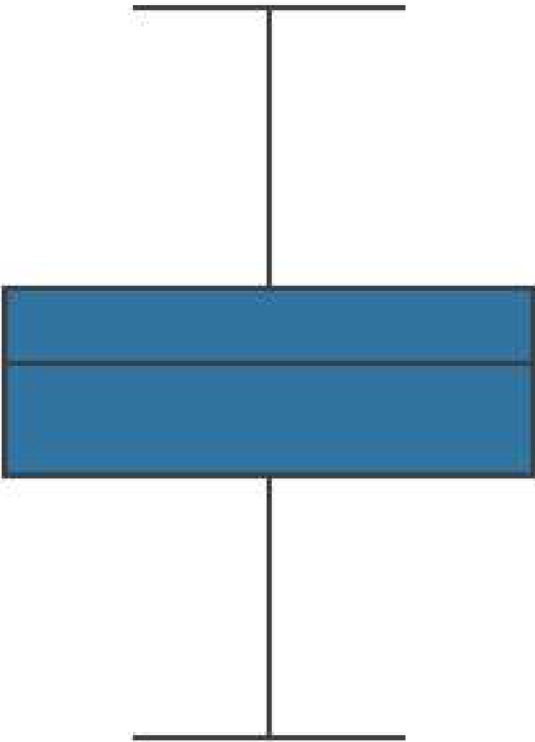70

Boxplot of Age by !Heart Disease Diagnosis

60

**Q)**

**50**

**40**

30

0 1

Heart Disease Diagnosis

In [22]: sns.scatterplot(x='chol', y='trestbps', data=datasetl) plt.title('Scatterplot of Cholesterol and Max Heart Rate') plt.xlabel('Cholesterol')

plt.ylabel('Max Heart Rate') pH.show()

Scatterplot of Cholesterol and Max Heart Rate

•

•

•

•

• •

*I*

•

•

•

•

• •

•

•

|  |  |
| --- | --- |
| 200 | - |
| 180 | - |
| 160 | - |
|  | • |
| 140 | - |
|  | • |
| 12.0 -  100 - | |

et'ri::,

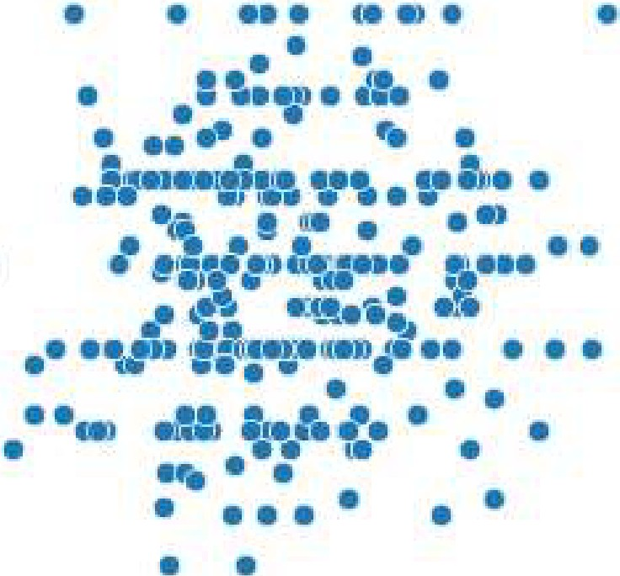

•

•

(tl

a,

I

rXn

:E:

2.00 300

Cholesteroi

400 500

In [12]: plt.hist(datasetl['age'], bins=10) plt.title('Histogram of Column age') plt.xlabel('Value') plt.ylabel('Frequency')

pH.show()

#### Histogram of Column age

**u**>,

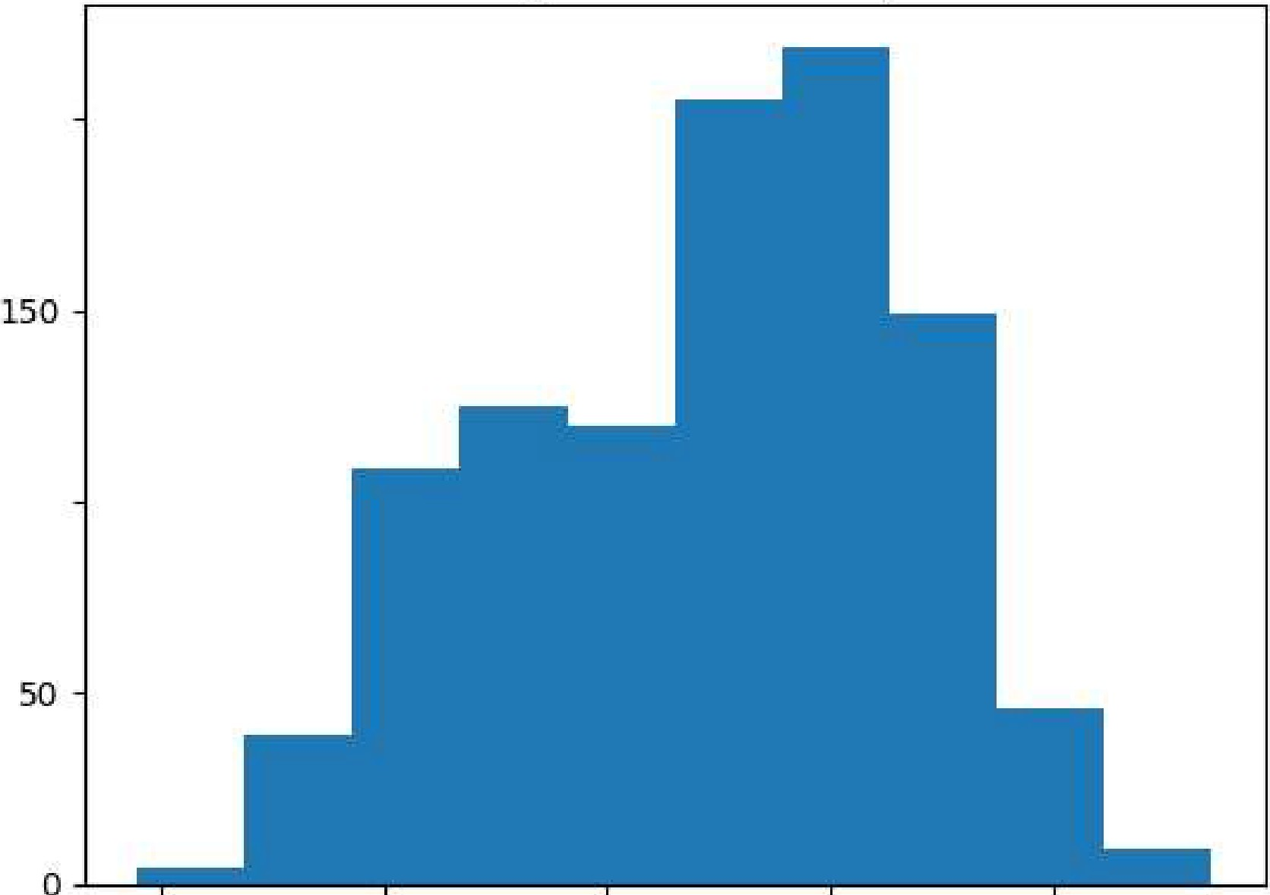

**200**

**100**

**i:::::**

**(J.l**

**:r:::rl**

w

**30 40 50 60 70**

**\/alue**

In [13]: sns.countplot(x='cp', data=datasetl) plt.title('Bar Chart of Column Name') plt.xlabel('Value') plt.ylabel('Frequency')

pH.show()

#### Bar Cbcrut of Column Name

**0** l 2. 3

**\lalue**

Air Quality

In [14]: plt.hist(dataset2['CO(GT)'J.dropna(), bins=10) plt.xlabel('CO Concentration') plt.ylabel('Count')

plt.title('Histogram of CO Concentration')

plt.xticks([0, 20, 40, 60, 80,100], ['0', '20', '40', '60', '80', '100'])

pH.show()

**4000**

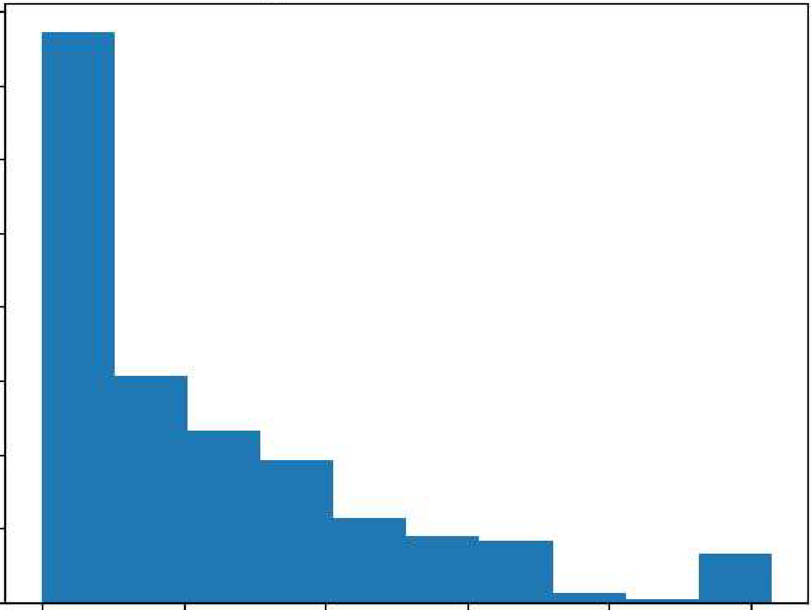

Histogram of CO Conc,entration

**3500**

**3000**

**2500**

a=jaal

**0**::::, **2000**

u

**1500**

**1000**

**500**

0

0 **20 40 60 80** 1.:00

CO Concentration

In [15]: sns.boxplot(y=dataset2['PT08.S1(CO)'J.dropna().astype(float)) plt.ylabel('CO Concentration')

plt.title('Box Plot of CO Concentration') pH.show()

**c**

**0**

**'.j:l**

**(U**

ii-.

2000

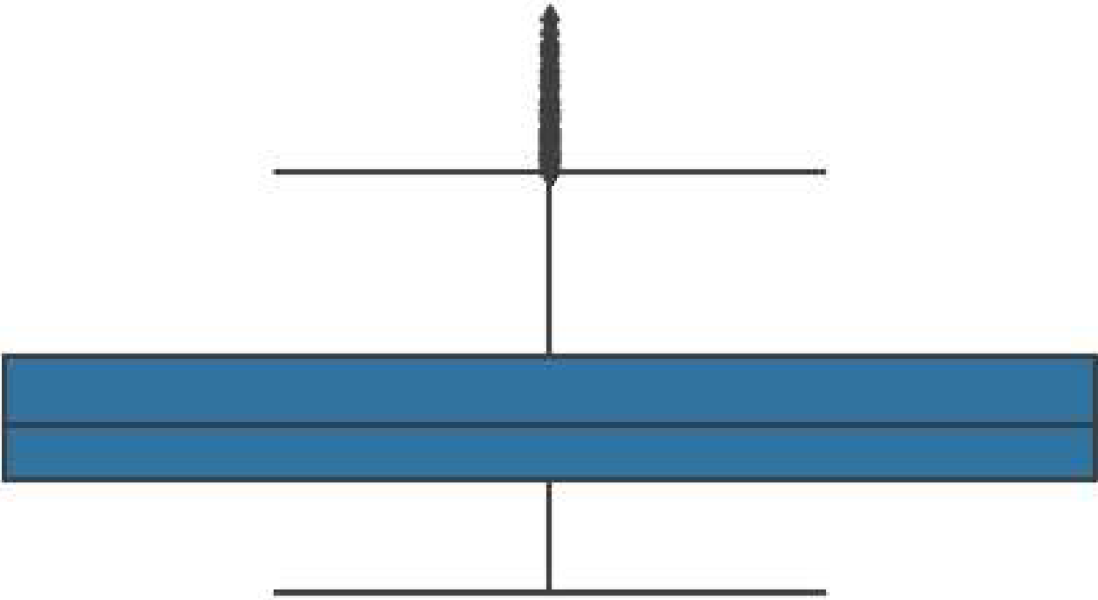1500

Box Plo,tof CO Concentration

•

**1= 1000**

**11)**

=**u**

**0u**

**0**

**u**

**500**

0

In [16]: sns.scatterplot(x='N02(GT)', y='CO(GT)', data=dataset2.dropna(subset=['N02(GT)', '1

plt.xlabel('CO Concentration') plt.ylabel('N02 Concentration')

plt.title('Scatter Plot of N02 and CO Concentrations')

pH.yticks([0, 20, 40, 60, 80,100], ['0', '20', '40', '60', '80', '100'])

pH.show()

###### Scaitter Plo,tof N02and CO Conc,entrations

**r::**

..9...

('!!

**,1,,.1**

fii

**u**

u0

N

0**z**

0

**20**

**40**

60

80

100

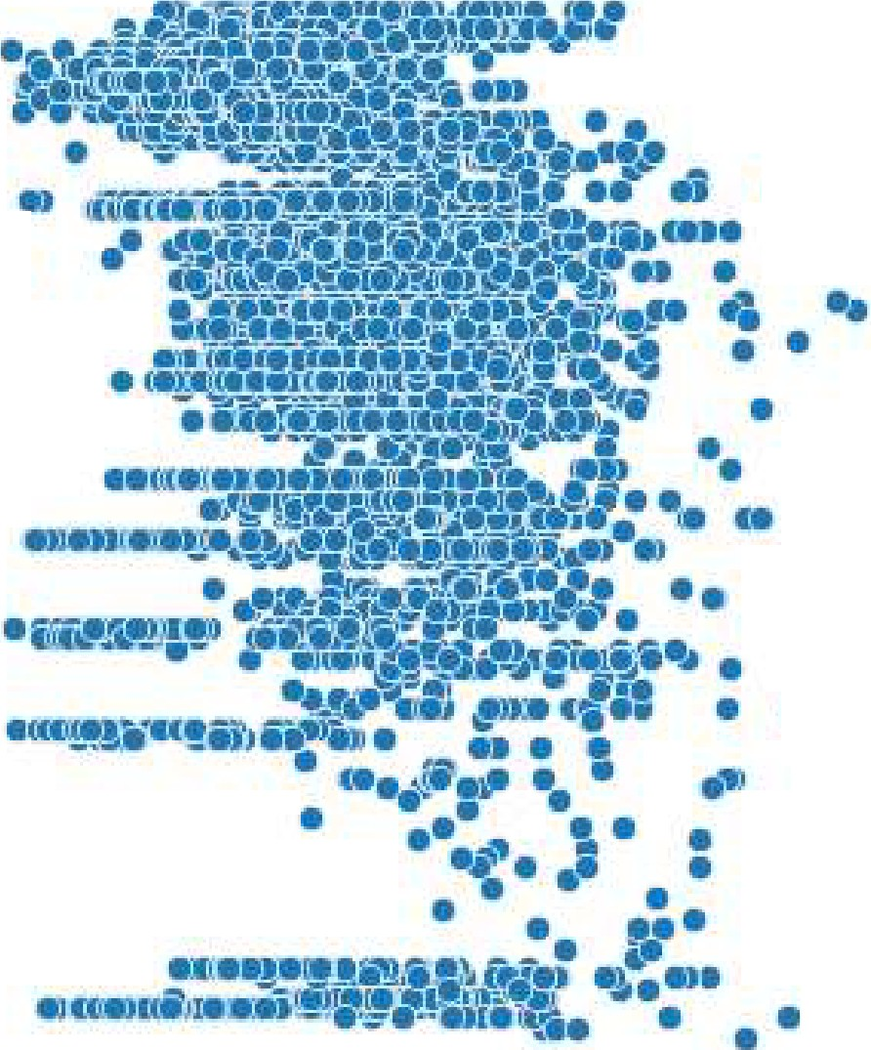

-200 -100 **0 100 200**

i

•I

i

••

;

I

•

•I

•••

•I!

!

**!I**

••

i

ii:

•

CO Concentration:

In [17]: sns.violinplot(y='NMHC(GT)', data=dataset2.dropna(subset=['NMHC(GT)'])) plt.ylabel('NMHC Concentration')

plt.title('Violin Plot of NMHC Concentration') pH.show()

###### Violin Plot of NMHC Concent1rntion

**1200**

**1000**

C **800**

**0**

'.µ

rn

**h.**

**'l:: 600**

**Q)**

**u**

**r::**

**0**

**V 400**

u

I

**z 2.00**

**0**

-200

**Title:**

### ASSIGNMENT NO: 8

Perform the following data visualization operations using Tableau on Adult and Iris datasets.

1. 1D (Linear) Data visualization
2. 2D (Planar) Data Visualization
3. 3D (Volumetric) Data Visualization
4. Temporal Data Visualization
5. Multidimensional Data Visualization
6. Tree/ Hierarchical Data visualization
7. Network Data visualization

**Problem Statement:**

Perform visualization using Tableau.

**Theory:**

Data visualization or data visualization is viewed by many disciplines as a modern equivalent of visual communication. It involves the creation and study of the visual representation of data, meaning "information that has been abstracted in some schematic form, including attributes or variables for the units of information".

Data visualization refers to the techniques used to communicate data or information by encoding it as visual objects (e.g., points, lines or bars) contained in graphics. The goal is to communicate information clearly and efficiently to users. It is one of the steps in data analysis or data science

**3D/Volumetric**

Broadly, examples of scientific visualization: 3D computer models

In 3D computer graphics, 3D modeling (or three-dimensional modeling) is the process of developing a mathematical representation of any surface of an object (either inanimate or living) in three dimensions via specialized software. The product is called a 3D model. Someone who works with 3D models may be referred to as a 3D artist. It can be displayed as a two-dimensional image through a process called 3D rendering or used in a computer simulation of physical phenomena. The model can also be physically created using 3D printing devices.

surface and volume rendering

Rendering is the process of generating an image from a model, by means of computer programs. The model is a description of three-dimensional objects in a strictly defined language or data structure. It would contain geometry, viewpoint, texture, lighting, and shading information. The image is a digital image or raster graphics image. The term

may be by analogy with an "artist's rendering" of a scene. 'Rendering' is also used to describe the process of calculating effects in a video editing file to produce final video output.

Volume rendering is a technique used to display a 2D projection of a 3D discretely sampled data set. A typical 3D data set is a group of 2D slice images acquired by a CT or MRI scanner. Usually these are acquired in a regular pattern (e.g., one slice every millimeter) and usually have a regular number of image pixels in a regular pattern. This is

an example of a regular volumetric grid, with each volume element, or voxel represented by a single value that is obtained by sampling the immediate area surrounding the voxel.

computer simulations

Computer simulation is a computer program, or network of computers, that attempts to simulate an abstract model of a particular system. Computer simulations have become a useful part of mathematical modeling of many natural systems in

physics, and computational physics, chemistry and biology; human systems in economics, psychology, and social science; and in the process of engineering and new technology, to gain insight into the operation of those systems, or to observe their behavior.[6] The simultaneous visualization and simulation of a system is called visulation.

Examples: Temporal

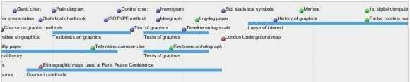

**timeline**

Tools: SIMILE Timeline, TimeFlow, Timeline JS,

ExcelImage:

Friendly, M. & Denis, D. J. (2001). Milestones in the history of thematic cartography, statistical graphics, and data visualization. Web

document, [http://www.datavis.ca/milestones/.](http://www.datavis.ca/milestones/) Accessed: August 30, 2012.

**time series**

**histogram**

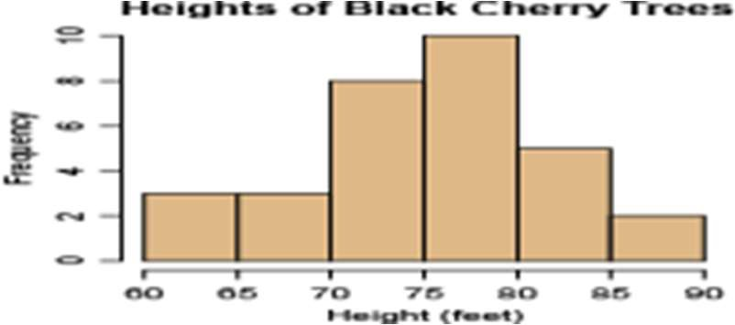

**pie chart**

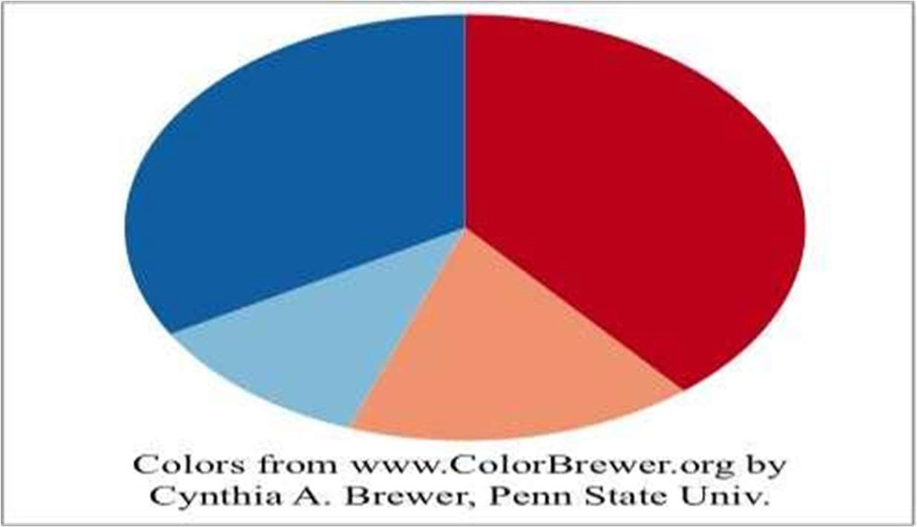

Examples:

general tree visualization

**dendrogram**

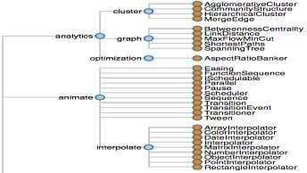

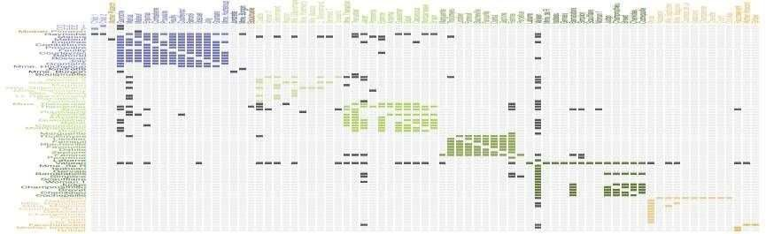Network

Examples:

matrix

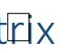• **node-link diagram (link-based layout algorithm)**

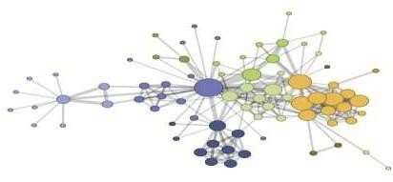

**Tableau:**

Tableau is a Business Intelligence tool for visually analyzing the data. Users can create and distribute an interactive and shareable dashboard, which depict the trends, variations, and density of the data in the form of graphs and charts. Tableau can connect to files, relational and Big Data sources to acquire and process data. The software allows data blending and real-time collaboration, which makes it very unique. It is used by businesses, academic researchers, and many government organizations for visual data analysis. It is also

positionedas a leader Business Intelligence and Analytics Platform in Gartner Magic Quadrant.

**Tableau Features:**

Tableau provides solutions for all kinds of industries, departments, and data environments. Following are some unique features which enable Tableau to handle diverse scenarios.

* **Speed of Analysis** − As it does not require high level of programming expertise, any user with access to data can start using it to derive value from the data.
* **Self-Reliant** − Tableau does not need a complex software setup. The desktop version which is used by most users is easily installed and contains all the features needed to start and complete data analysis.
* **Visual Discovery** − The user explores and analyzes the data by using visual tools likecolors, trend lines, charts, and graphs. There is very little script to be written as nearlyeverything is done by drag and drop.
* **Blend Diverse Data Sets** − Tableau allows you to blend different relational, semi structured and raw data sources in real time, without expensive up-front integration costs. The users don’t need to know the details of how data is stored.
* **Architecture Agnostic** − Tableau works in all kinds of devices where data flows. Hence, the user need not worry about specific hardware or software requirements to use Tableau.
* **Real-Time Collaboration** − Tableau can filter, sort, and discuss data on the fly and embed a live dashboard in portals like SharePoint site or Salesforce. You can save your view of data and allow colleagues to subscribe to your interactive dashboards sothey see the very latest data just by refreshing their web browser.
* **Centralized Data** − Tableau server provides a centralized location to manage all of

the organization’s published data sources. You can delete, change permissions, add tags, and manage schedules in one convenient location. It’s easy to schedule extract refreshes and manage them in the data server. Administrators can centrally define a schedule for extracts on the server for both incremental and full refreshes. There are three basic steps involved in creating any Tableau data analysis report. These three steps are-

* **Connect to a data source** − It involves locating the data and using an appropriatetype of connection to read the data.
* **Choose dimensions and measures** − This involves selecting the required columnsfrom the source data for analysis.
* **Apply visualization technique** − This involves applying required visualization methods, such as a specific chart or graph type to the data being analyzed.

For convenience, let’s use the sample data set that comes with Tableau installation named sample – superstore.xls. Locate the installation folder of Tableau and go to **My Tableau Repository**. Under it, you will find the above file at **Datasources\9.2\en_US-US**.

Connect to a Data Source

On opening Tableau, you will get the start page showing various data sources. Under the header **“Connect”**, you have options to choose a file or server or saved data source. Under Files, choose excel. Then navigate to the file **“Sample – Superstore.xls”** as mentioned above. The excel file has three sheets named Orders, People and Returns. Choose **Orders**.

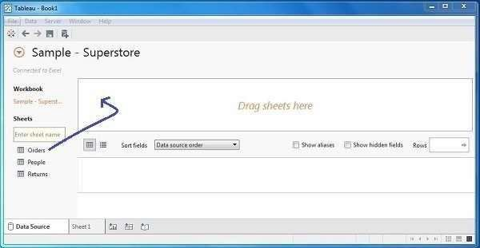

Choose the Dimensions and Measures

Next, choose the data to be analyzed by deciding on the dimensions and measures. Dimensions are the descriptive data while measures are numeric data. When put together, they help visualize the performance ofthe dimensional data with respect to the data which are measures. Choose **Category** and **Region** as the dimensions and **Sales** as the measure. Drag

and drop them as shown in the following screenshot. The result shows the total sales in each category for each region

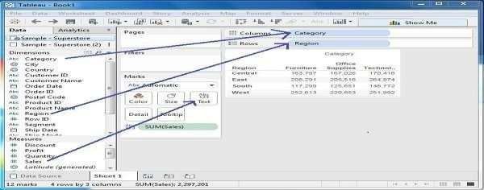

Apply Visualization Technique

In the previous step, you can see that the data is available only as numbers.

You have to readand calculate each of the values to judge the performance. However, you can see them as graphs or charts with different colors to make a quicker judgment.

We drag and drop the sum (sales) column from the Marks tab to the Columns shelf. The table showing the numeric values of sales now turns into a bar chart automatically.

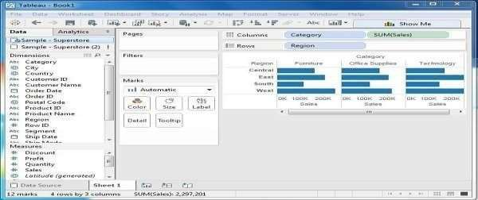

You can apply a technique of adding another dimension to the existing data. This will add more colors to the existing bar chart as shown in the following screenshot.

**Data visualization using Tableu:**

1. **Iris Dataset**

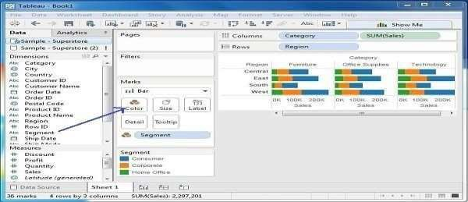

1-bluu-Bool:l·f aullc-..npwftlfl1 dlyS

..

Re Oi,i, Worlr.shtfl I'll SlOfy All-,,sb p F(JflM Sel'Ytr WinOOw ,..p

" r..

***l*** . T *(I* Standard - I.:· Q < P'ShowMe

o.,., ' ..... **ac.,...,.**

i¥Wiibbl *P.*IIM

i111'ii'4tht: J.M

*... llk.nurrN..,_*

* + PelalL.erislhCm
  + .alWdtl'ICm

'" LqthCm

* + St-paiWl<llhtm
  + *lmav( t)*

6J IIl

*.:.* 0 i

"­

Relation between Petal Length and Petal Width

"

20

- • I , I;

**'I** o >o '

.,_-5

CJ HI!

..s. i14

*i* 12

08

- '

r:«seatttrl)lotstry Oormon

2104

....

"°"

30 35 41) 45 50 55 60 65 70

Pt1alletigth(,-.

oruu,o,,,,c:.

m-.1,o,,,1>yl , i. ,.,c,,,t IOO

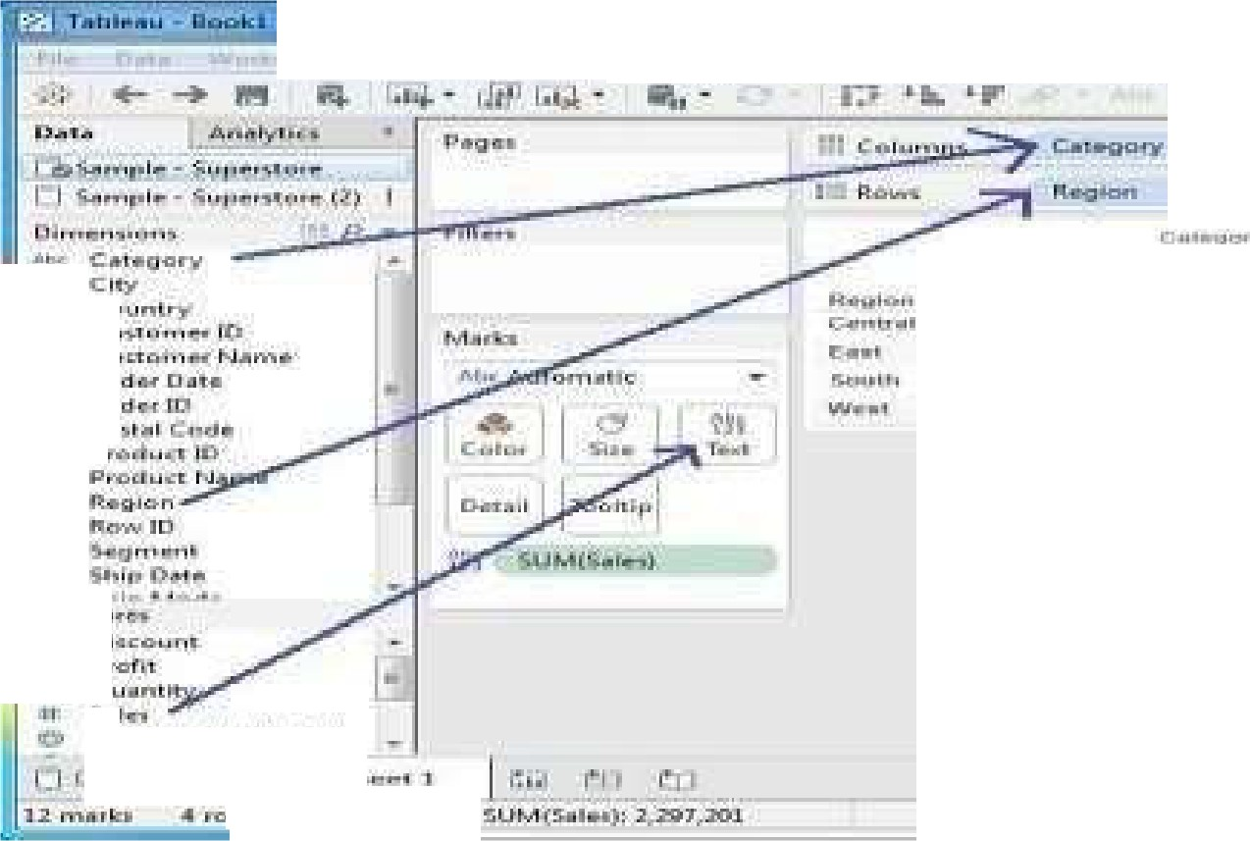

---

11- .. 1:::1-- -x.- *-:*

-- - - - - ---

**l,1111** -

**0**

0

-IJ T1l Rt!.,,, !fl

r;,un

0

,in-,: CLl Mi'iiN NJIIIM•'

r, Ori:I'

ll'i Or

i hlldnilhii

1 -l'i'!I.,.

ql"l=-'=11

U1lfll:tm1

"''

1.... 11

1r.raM

.l!,1,-.

I l"C1 r

......

(PPll4"' ,JI

, ., :.\•fl

I

**;!;JO""**

'

-

lllr'I PT=

11CitL P

**Gj,,,**

'

...'..

l'.:J

)i .......

'CIH,\i

I **DI**

**at•**

**'l't•** I':

ijJ **q**

,..

i.,w l;iS":J .:,alu rn.n,

1,

.i41



fff Dru, Wootsllttt DdlbNrcl SIO!f ANlyvs M., f«111a1 X'lfff Window Http



t *q* Standa'd • 6·9 <

* 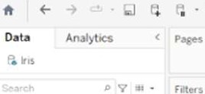C.0.-

CSWl#lfi■MM 4i1i'P#fihfa&

Tables

* 1Ull, St,.N.Jn'/flS
* P.lal On
* f'flalVIIIIIIICm

.. Sel)M On

.. palWldlllCm

* *JMa11(COult)*

.. 6J w

e.,,. .. L,t,ot

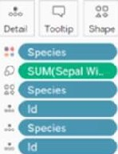

Relation between Sepal length andSepal Width

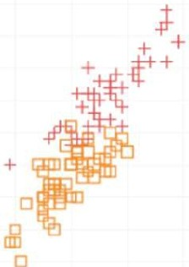.",

15

E]·,, ,I.

!Ill



"'

..

1. -'-' lrc,,,, ICOUN> SlU(SeNILqtt,0n)816!00

.

i.blHu·Booll:1• ,uloc:en:setq)lresilll•cMi¥S

..

l'ik 0.t.l Worbllttt SICIIJ' Anll)'n N4p fCIITllll WillOCIW Help

- 0 X

**ft** - I.Ifl. .***,I*** . 0 **.r** !· '

Siandard • **DJ·<;>** < ShowMe

.C.a.ta.

--

Tables Specits/111

....

'"'"""' ' .....

"V •. '*=

."".".'.".'"'

11 11 :, .. ,s 16 17 ln5 P"t0! -

18 I

II I I.;

.,,

* + PetallqttlCffl - "'

""

alWtdthCm .. 6J

.I_D

t Stp,11Ltf1itl\Cm

...

....

* + Slpa!WclthCm c;,

,

*lnscsv(COUtltJ*

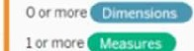

! .

Hi!

Fctllontontalbars

1 11'1H:·!II:,11.1•

* i'iih·li·itl◄

:I1111111 11l1ll1111111111**l1ll1**11 I**11**11

,5 .s ,5 5 *5* •s *5* ,5 ,5 .s ,5 s ,5 ,5 .s ,5 !r

! t ! r ! ! ! ! ! ! ! ! ! t t t ! t

£

£ £ £

6 £ £ £ £ £ 6

£

j ! **l** ! j j ! ! ! ! j j ! l j ! j l

......, ShNtl4

"

* - 1,-t,, - SUMd- -111911AOO

**Adult dataset :**

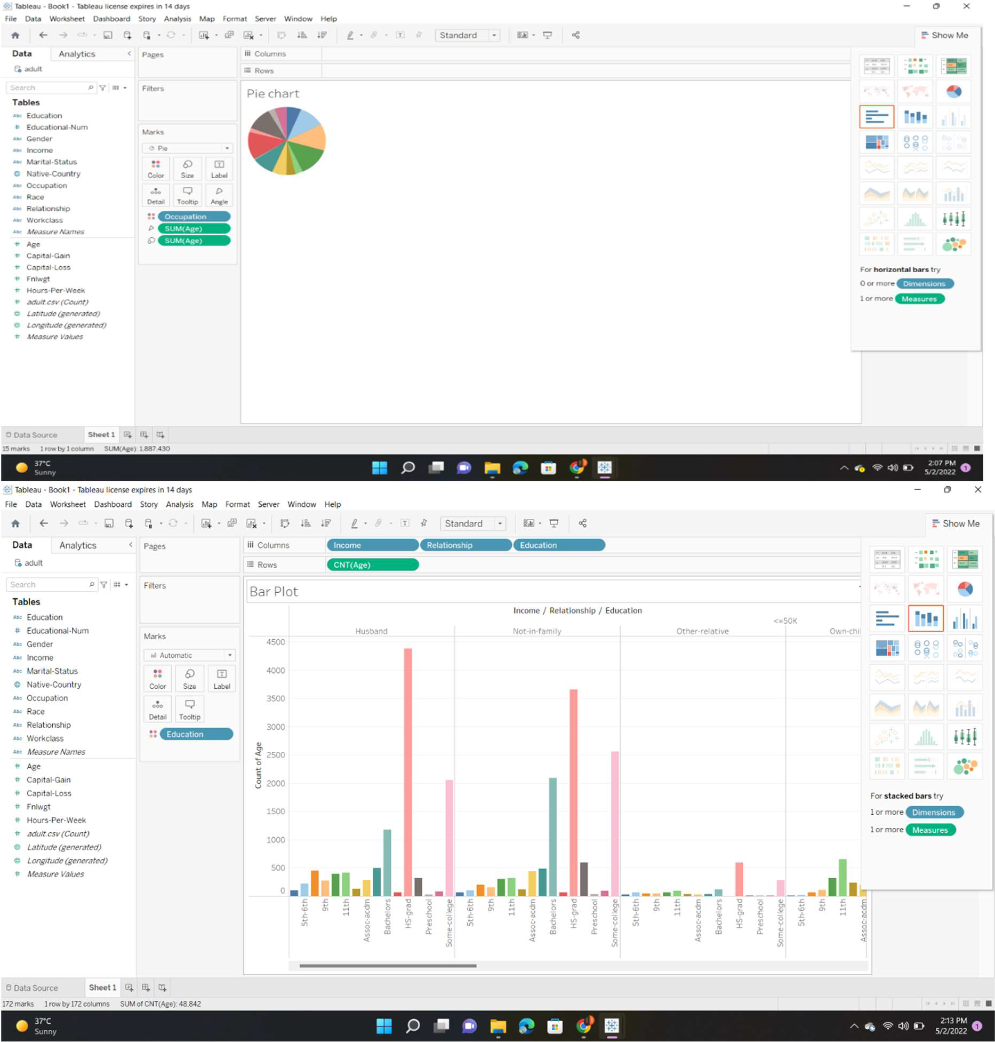

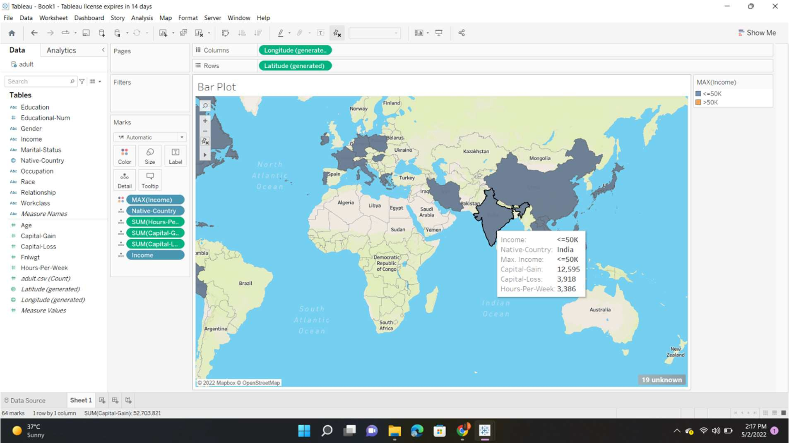

**Conclusion:**

Thus we have learnt how to Visualize the data in different types (1 1D (Linear) Data visualization,2D (Planar) Data Visualization, 3D (Volumetric) Data Visualization, Temporal Data Visualization,Multidimensional Data Visualization, Tree/Hierarchical Data visualization, Network Data visualization) by using Tableau Software.